PREPARED BY:  <Name>  <Department> | APPROVED BY:  <Name>  <Department> | APPROVED BY:  <Name>  <Department>
APPROVED BY:  <Name>  <Department> | APPROVED BY:  <Name>  <Department> | APPROVED BY:  <Name>  <Department>
PROPRIETARY NOTICE
This Document contains proprietary information and such information shall not be disclosed to others for any purpose or used for manufacturing without written permission from Ingersoll Rand. Printed copies are not controlled.

REVISION HISTORY
REV. NO. | DATE | DESCRIPTION | CHECKED | APPROVED
0 | <12-Feb-2019> | Initial Release
1
2
3
DISTRIBUTION:
<This field is not being used currently>

1. Introduction

1.1 Purpose
This document will provide details for configuring both Siemens ST-1200 and INSIGHTqc controller, aslo start to run the ST-1200 and INSIGHTqc controller in same Profinet subnet.

1.2 Reference Documents
Table 1: Reference Documents
Name | Rev # | Released date | Owner(s) | Location
ST-1200 Startup Kits

1.3 Hardware
Siemens ST-1200 PLC
- Network cables
- Laptop/PC
- INSIGHTqc Controller
1.4 Other Dependent Tools/Documents
<List any other tools or document needed for testing.>

2. Hardware Setup
Connect the hardware (see Figure 1): the Profinet(LAN) port on the ST-1200, the Ethernet Port2 of INSIGHTqc Controller and the network port of the computer that is running the Siemens Step7 application are connected via a network switch. The DHCP server is optional. This document was written using V13 of the Siemens Step 7 software and version 4.1.3 of the Siemens ST-1200 PLC firmware. Upgrading to a later version of the Step 7 software (current version V15) will require corresponding changes to the PLC firmware and upgrading licenses.
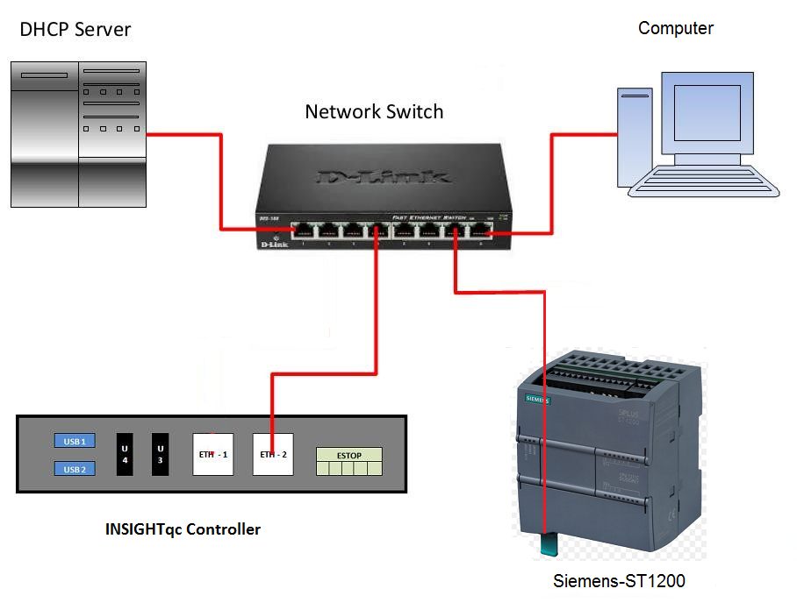 Figure 1: Hardware Connection

Enable Profinet on INSIGHTqc Controller
Go to the Profinet Settings page of the INSIGHTqc Controller, select Profinet and enable it (See Figure 2)

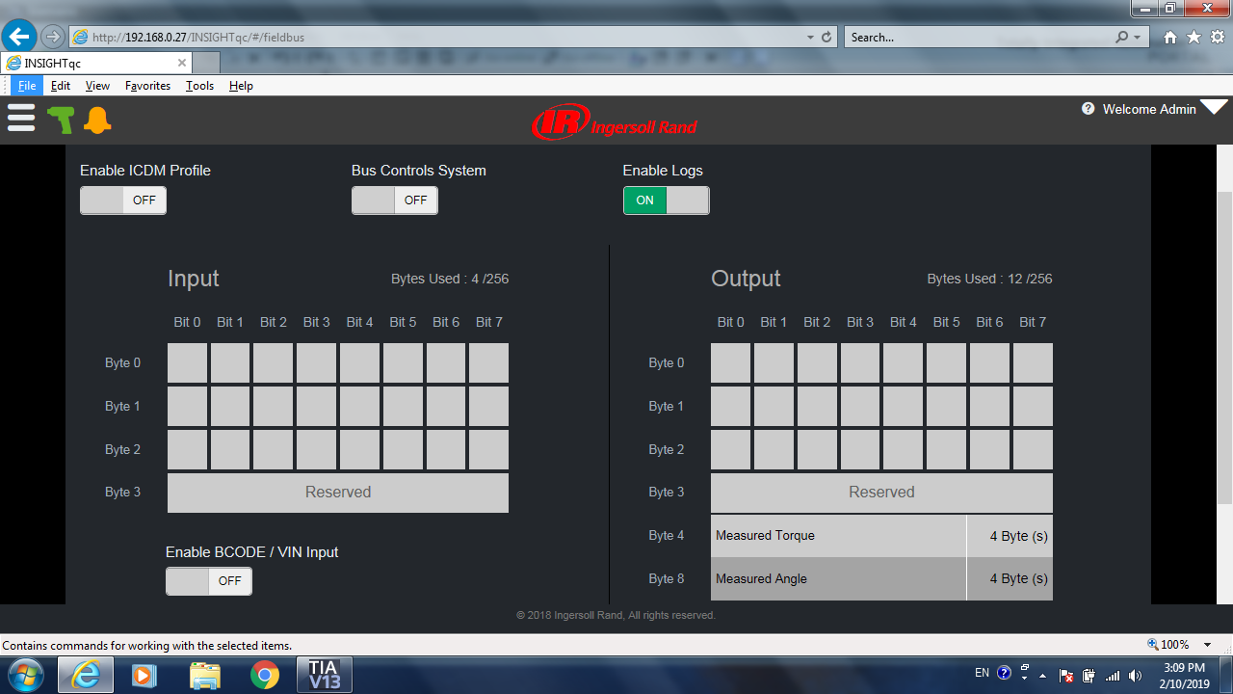
Figure 2. Profinet Setting page on INSIGHTqc Controller
When Profinet is enabled, Fieldbus icon on the Main Screen of INSIGHTqc Controller will turn Red. (See Figure 3)
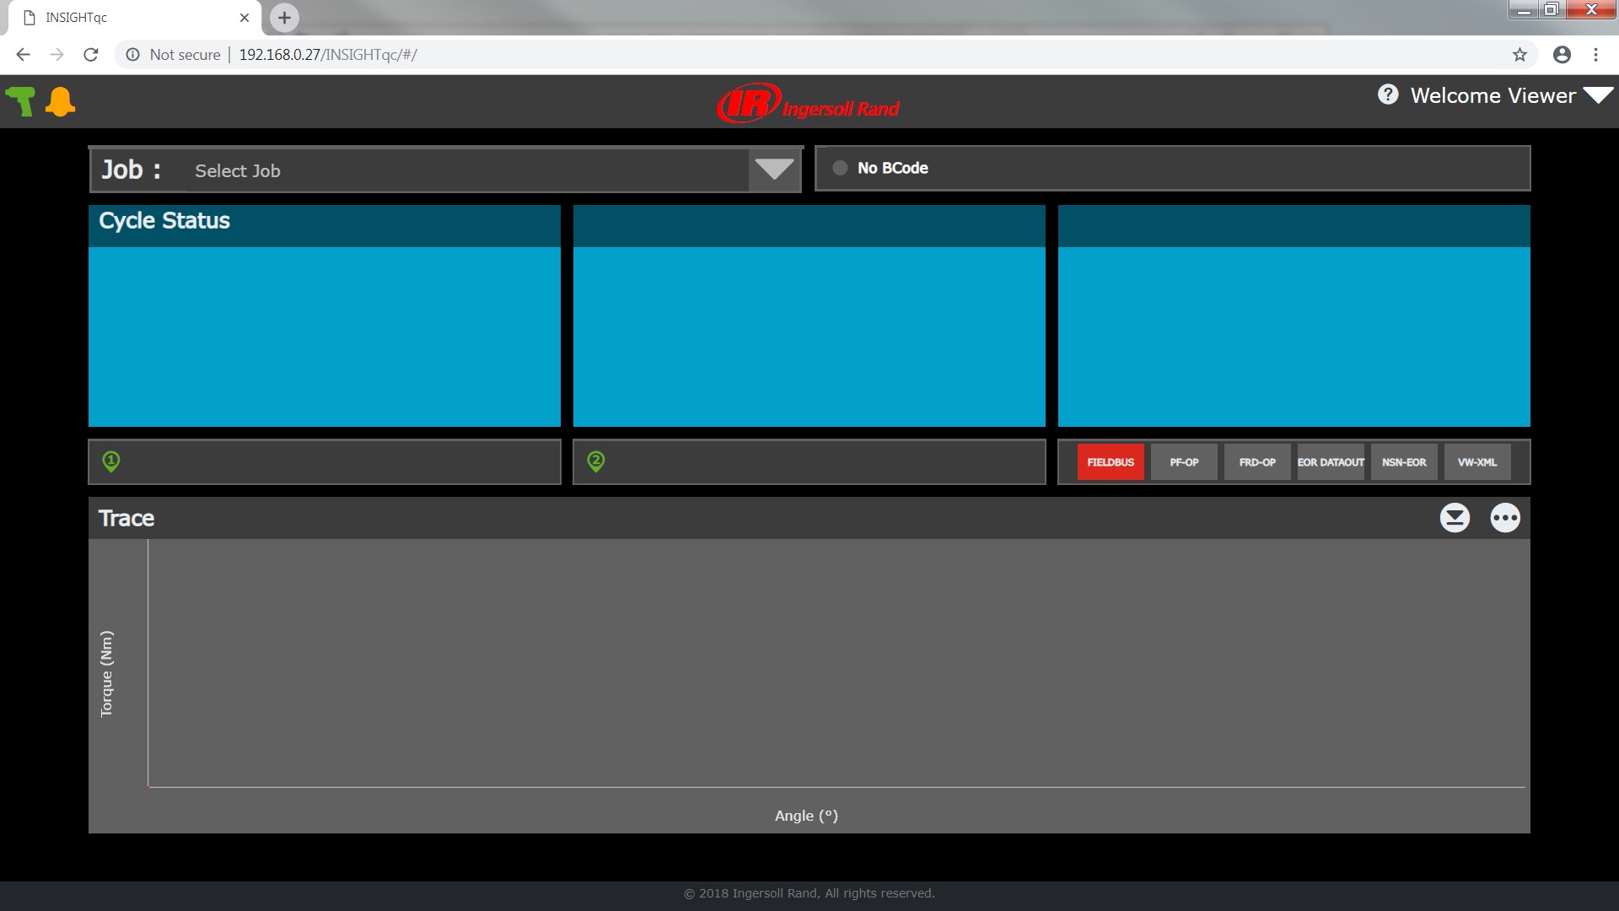

Figure 3. INSIGHTqc Controller Main Screen

Set up Profinet Device Name and IP Address on InsightQC

Setup IP Address
Start Step7, go to “Online & Diagnostics” and “Accessible devices” then press “Start search” button.
Click on the device with INSIGHTqc MAC address and Click “Show” button (See Figure 4)

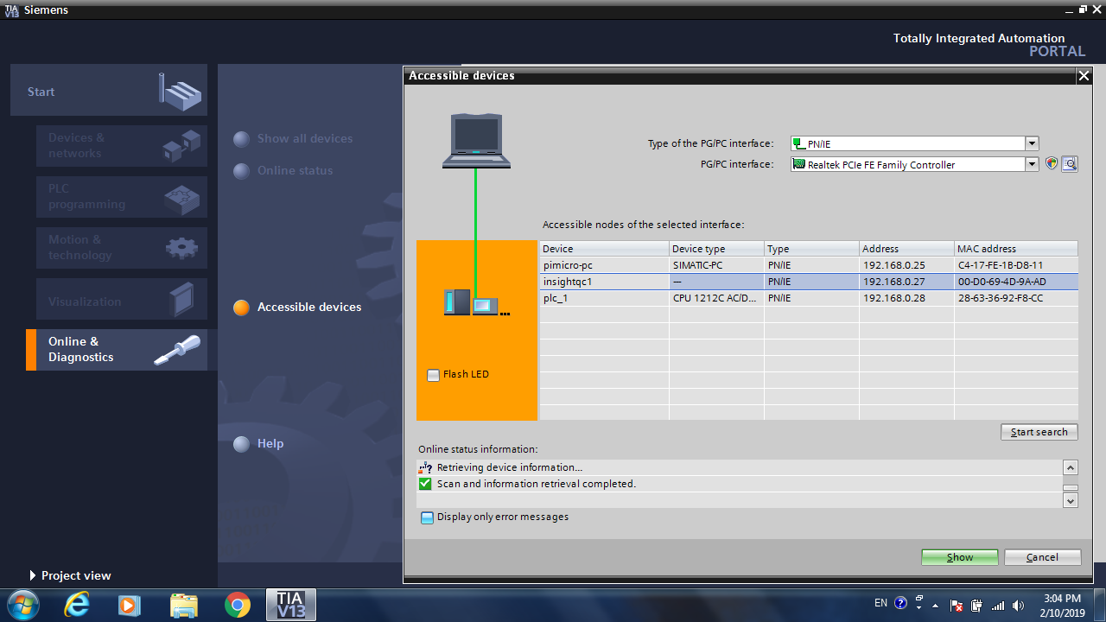

Figure 4. Accessible devices
The screen in Figure 5 can now be generated after pressing “Show” .
Look under “Online access” menu to find the network controller of the PC in Project tree on left side.
Under the network, click “Online & diagnostics” of INSIGHTqc device, then “Online & diagnostics” page for this device is shown on right.
Select “Assign IP address” under Functions menu to change and assign IP address (see Figure 5)
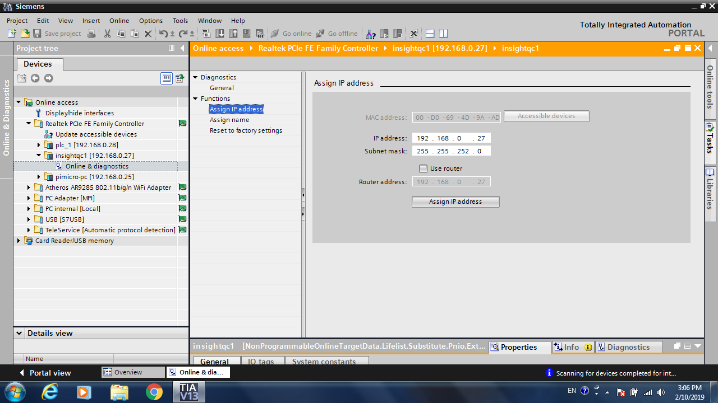
Figure 5 INSIGHTqc IP Address Assign Page

Set up Profinet Device Name
Click “Assign name” under Functions menu to change PROFINET device name and Assign name. (See Figure 6)
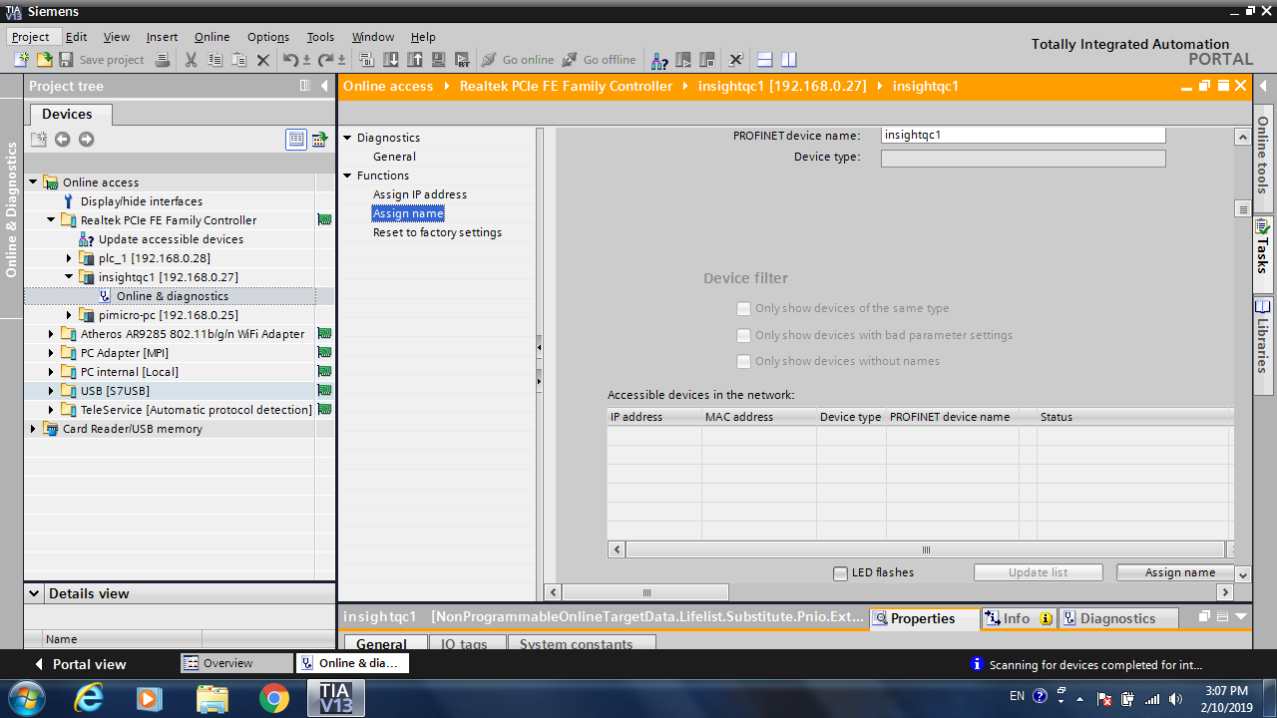
Figure 6. INSIGHTqc Assign name page

Set up Profinet Device Name and IP Address on ST-1200 PLC
Repeat the same procedure for the ST-1200 PLC. The ST-1200 should have a designator plc_1 and will also be located under the network controller for the PC. Use the Online & diagnostics screen in the same way to “Assign IP address” and “Assign name” (See Figure 7 and Figure 8)

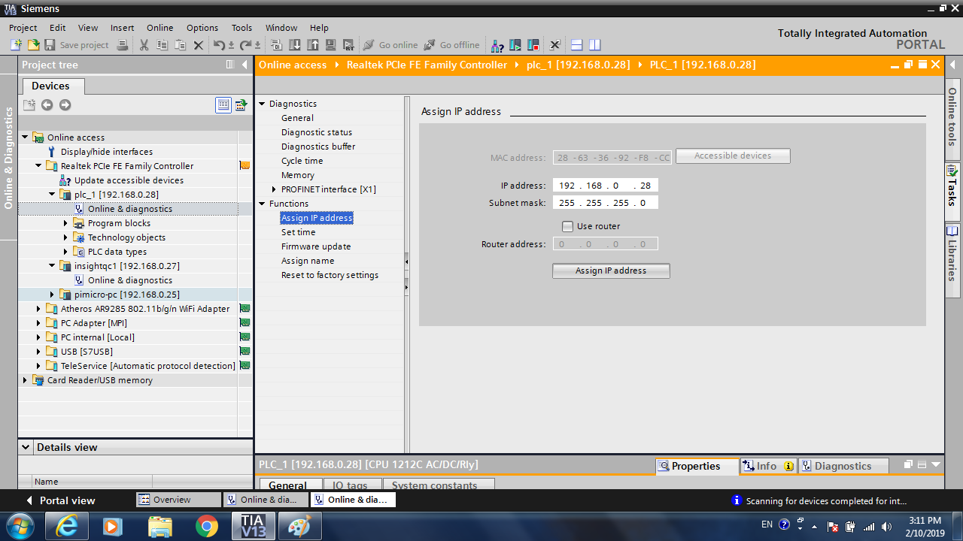

Figure 7. PLC Assign IP address page
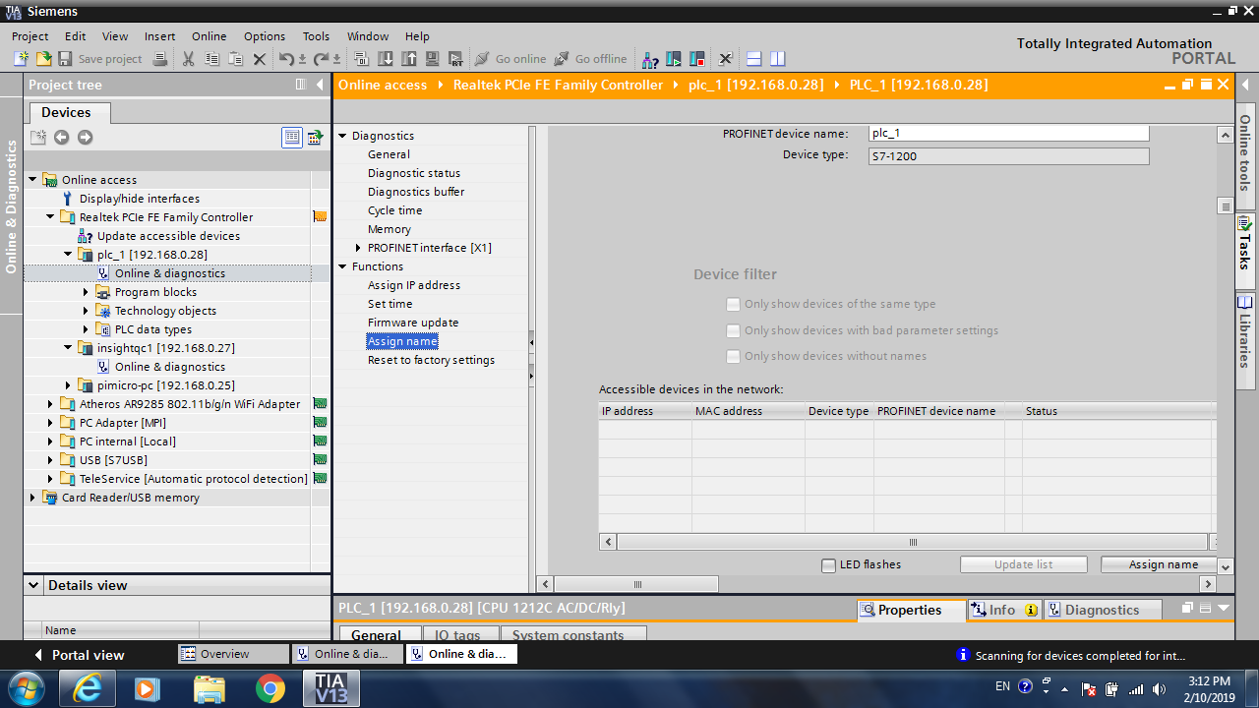

Figure 8. PLC Assign name page

Place, Configure and Connect InsightQC and ST-1200 in Network

6.1 Create Project
At the lower left of the screen in Figure 8 – press the Portal View.
The screen for the new project page in Step 7 should appear (See Figure 9)
Press Start the Create New Project
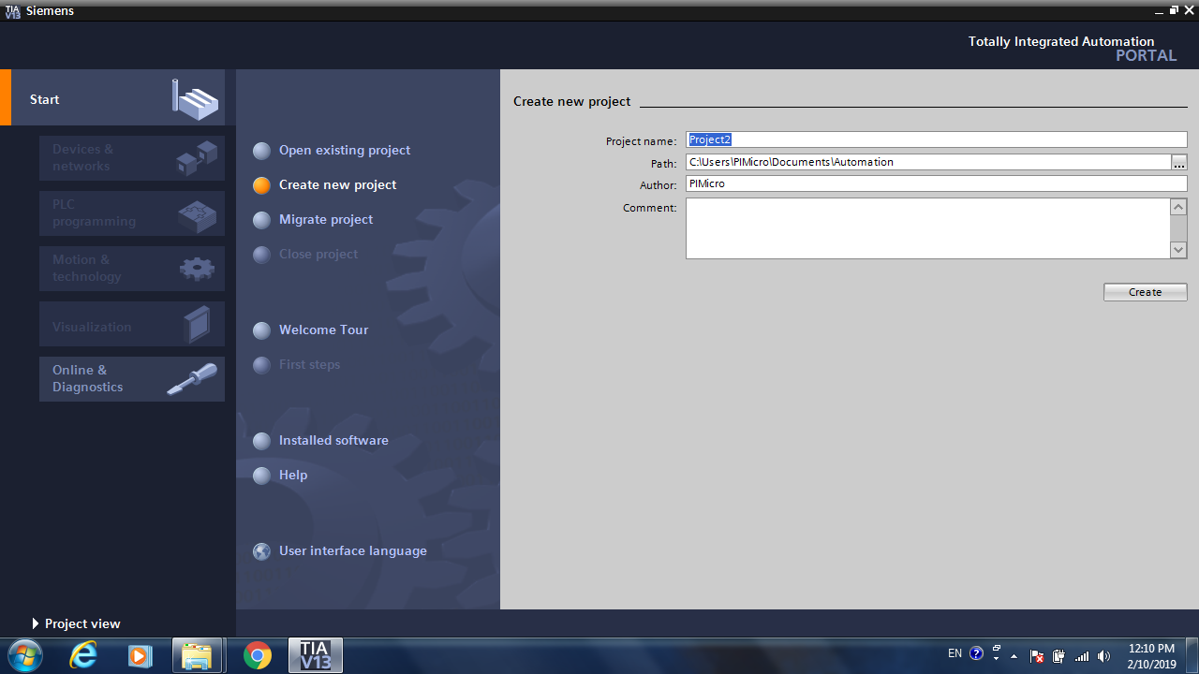

Figure 9. Create New Project
Go to “Configure a device” in Start menu. (See Figure 10)
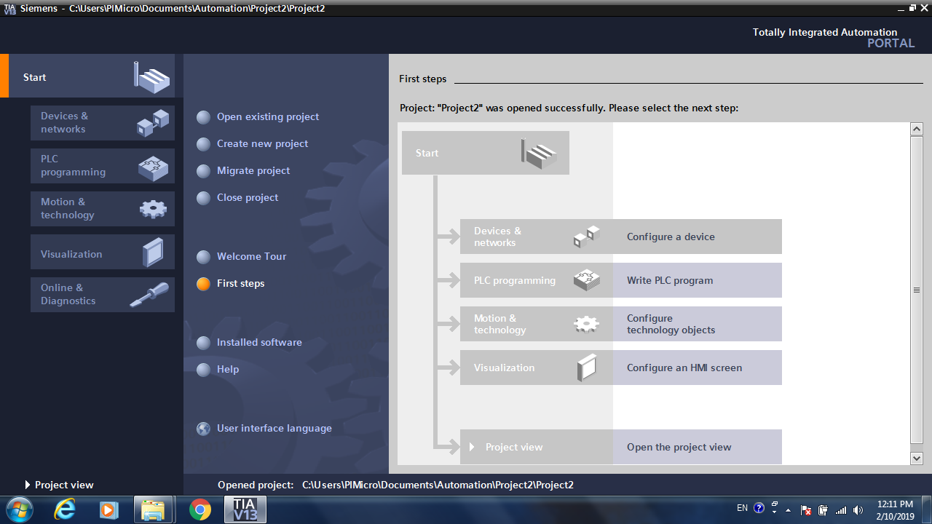

Figure 10. Project Start menu

6.2 Add PLC
Click “Add new device” button in “Device & network” menu, “Add new device” page is shown on right side.
Select ST-1200 CPU—1212C AC/DC/Rly and a proper version. Currently the CPU of the connected ST-12000 has V4.1. (See Figure 11)
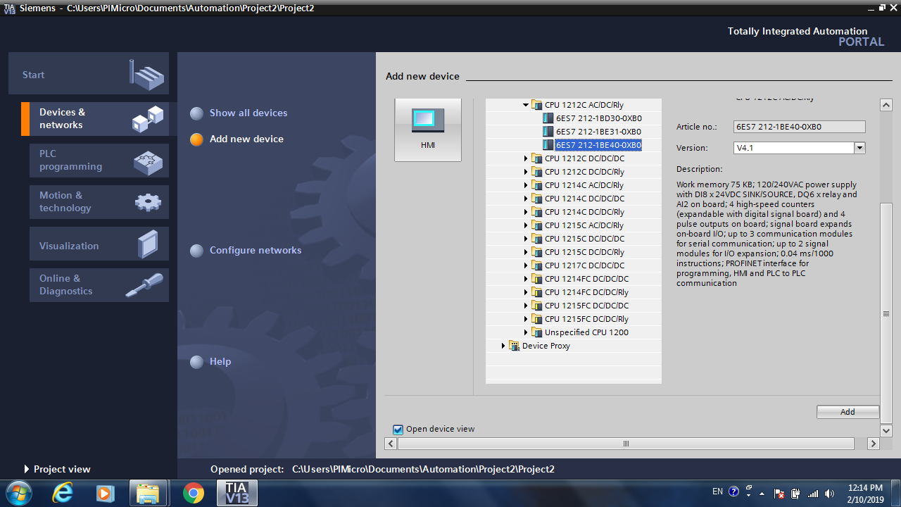

Figure 11. Add new device page

Press the Properties and General Tabs in the dialog below the PLC_1 icon
Press the “Add new subnet” button and PN/IE_1 should appear
Set the IP address the same as the IP address of ST1200 that is connected and previously assigned.
Set PROFINET device name the same the name of ST1200 that is connected and previously assigned
Uncheck “Generate PROFINET device names automatically” (See Figure 12)
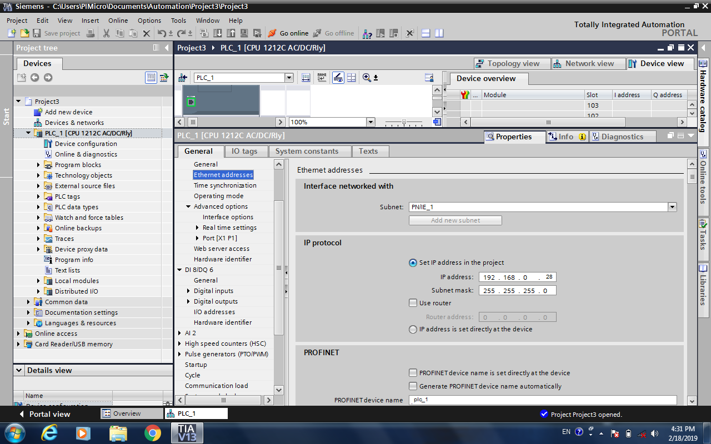

Figure 12. PLC Properties page

At the top of the screen press the Network View tab.
A PLC (PLC_1) and a Profinet bus (PN/IE_1) are shown in Network view. (See Figure 13)

Add INSIGHTqc
To import the INSIGHTqc controller into the hardware catalog, select the Options menu item at the top of the screen then “Manage general station description file (GSD)”. (See Figure 13)

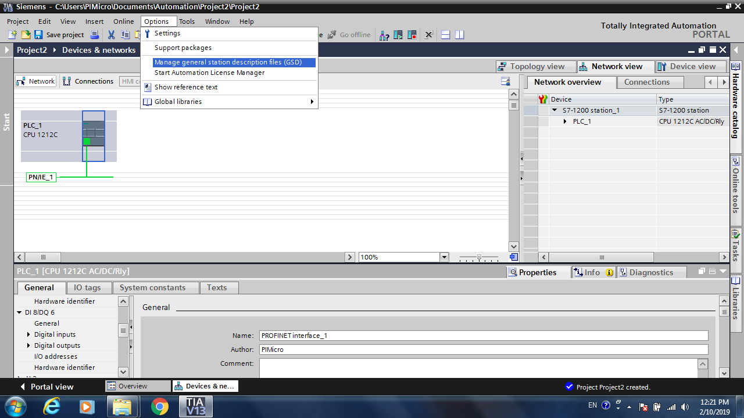

Figure 13. Import new hardware

Use the ellipsis button to select the directory where the GSDML file resides
Select the IR GSD file to install. (See Figure 14). Our current IR GSD file is ‘GSDML-V2.31-port-PORT_44in_256out-20171114.xml
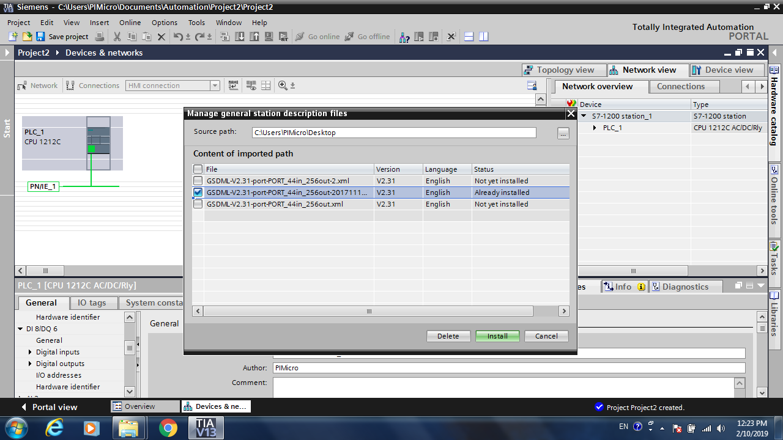

Figure 14. Select GSD file
To add INSIGHTqc in the project, open “Hardware Catalog” in the tabs on the right side of the screen. The “Hardware Catalog” tab is only visible if Device configuration on the left is highlighted.
Then select “Other field devices”/PROFINET IO/IO/port GMBH/port GMBH/Port IO Example to find the INSIGHTqc device, which is named Standard _44_256.
Drag it to the network view. (See Figure 15). It has a default name—portIODev1.

- 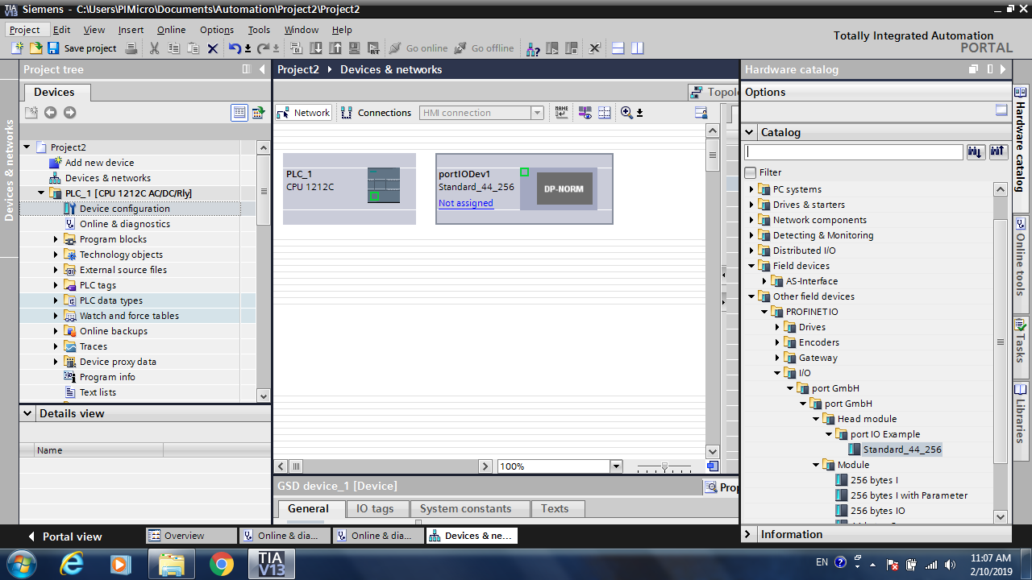

Figure 15. Add New Device from Hardware Catalog

Highlight the PortIODev1 icon
Press the Device View tab above it.
Expand the Module Heading in the Options Menu
Drag “256 bytes I” and “44 byte O” modules from Hardware Catalog for portIODev1 (INSIGHTqc) to Device Overview in the two open entries below the Interface entry. (see Figure 16)

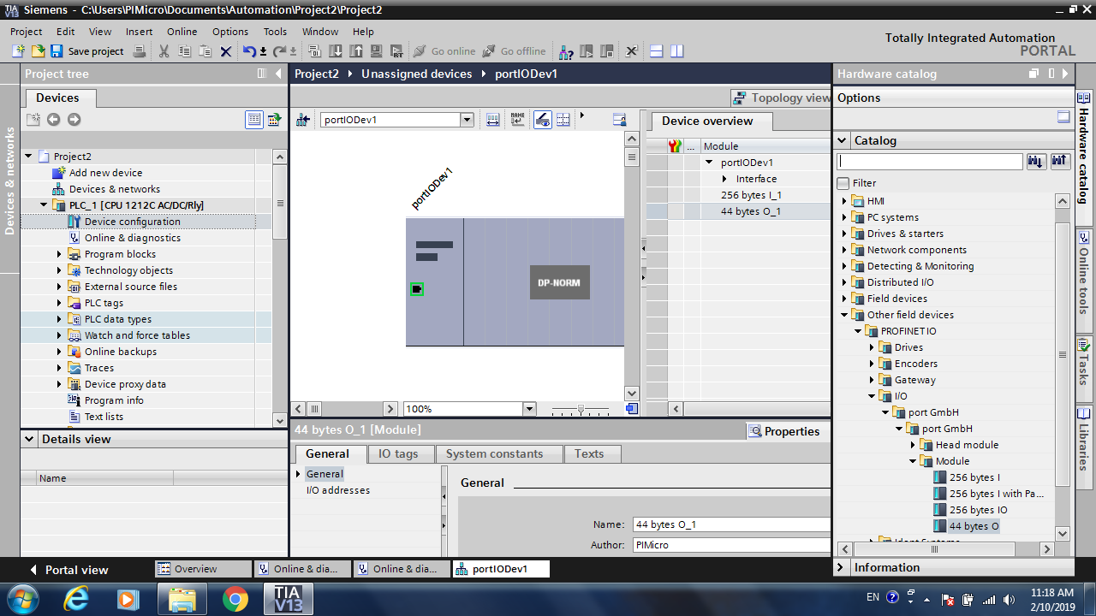

Figure 16. Add Modules into INSIGHTqc
Highlight portIODev1 then select the Properties and General Tabs Below the portIODev1 icon (INSIGHTqc).
In “Interface Networked With” select PN/IE_1 (do not press Add new subnet). PN/IE_1 Profinet subnet is the same subnet that PLC_1 is on.
Select “IP address is set directly at the device”.
Set PROFINET device name as same as the device name of the Insight QC controller that is connected and assigned before (insightqc1). (See Figure 17)
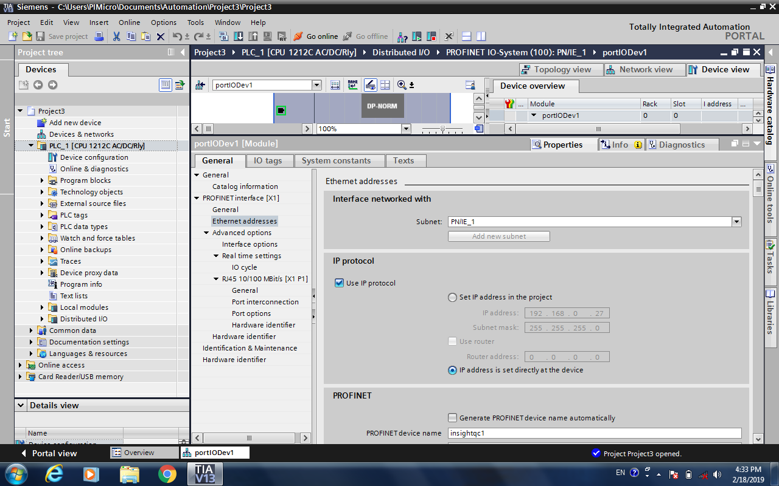

Figure 17. Configure Ethernet Address & Name

Press the “Network view” tab at the top of the screen.
Move the mouse over the green square in the PLC icon and hold the left mouse button down.
Drag a line to the green square in the portIODev1 (InsightQC)
The screen in Figure 18 should appear.

7. Run Profinet Network

7.1 Download Configurations
If the PLC is running press the “Stop” button circled in blue below.
Then press “Download to device” circled in yellow below.
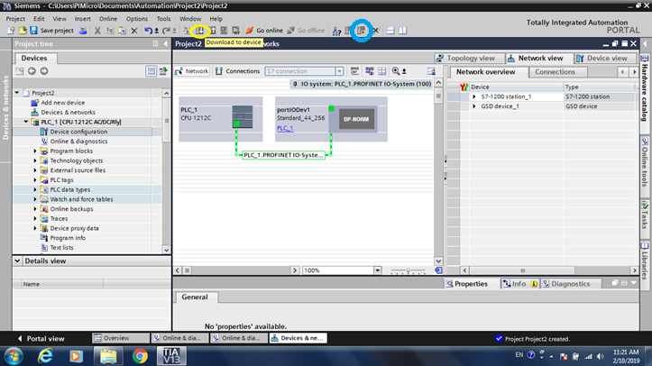

Figure 18. Download to Device

The screen in Figure 19 should appear

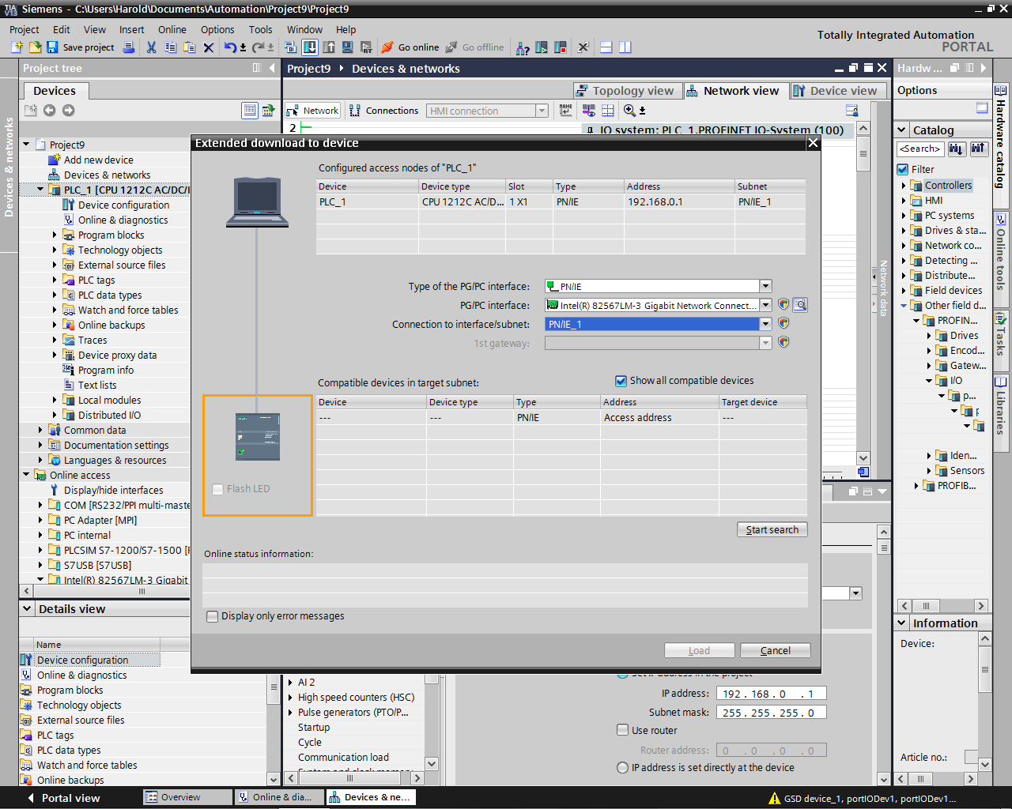

Figure 19 Extended Download to Device

Connection to interface/subnet should also show PN/IE_1
Press Start Search – the PLC is shown in orange – then press Load then Load again then Finish

7.2 Setup for Real Time Settings
The real time settings are currently configured to default 2 msec cycle time with a watchdog of 3. If 3 consecutive 2ms packets are missed the unit will disconnect. These settings will not run. Ultimately we will put these values in the GSDML file and this step can be eliminated. We are currently using a 16 msec cycle time with a watchdog of 3. Highlight the InsightQC and in Properties/ProfinetInterface/AdvancedOptions/RealTimeSettings enter these values.

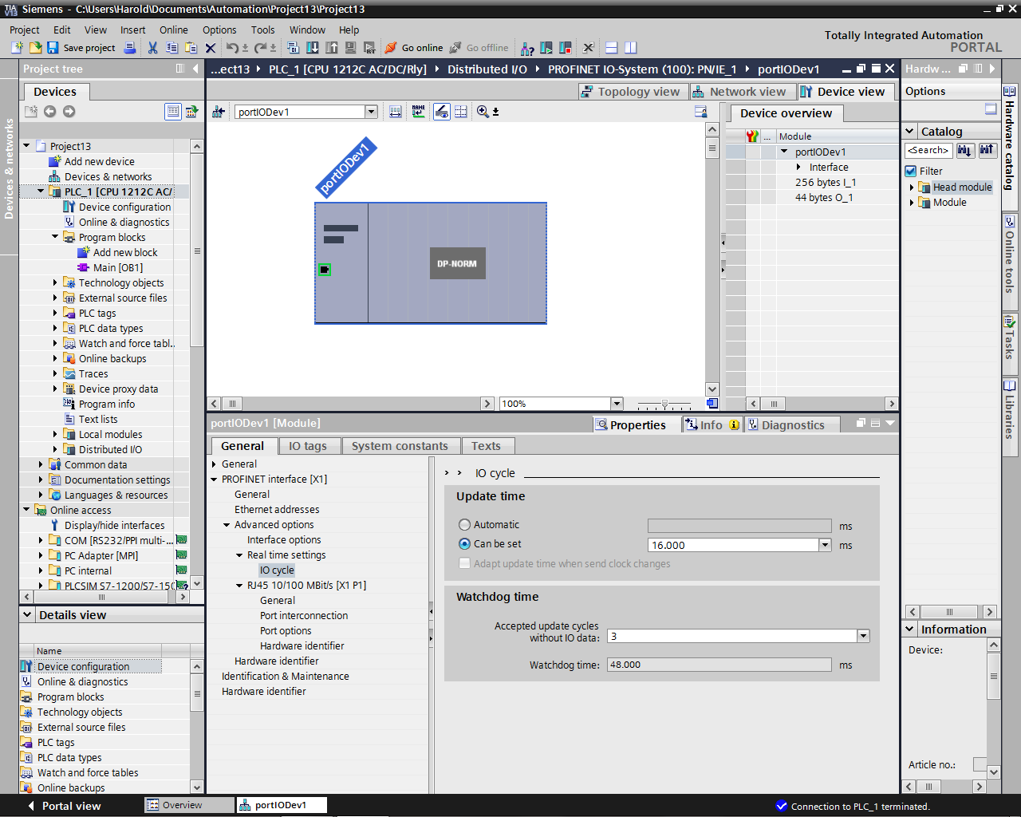
Following this, right click on the PLC and hit Compile HS & SW. Then hit download to device beneath it and download HW/SW to the PLC.

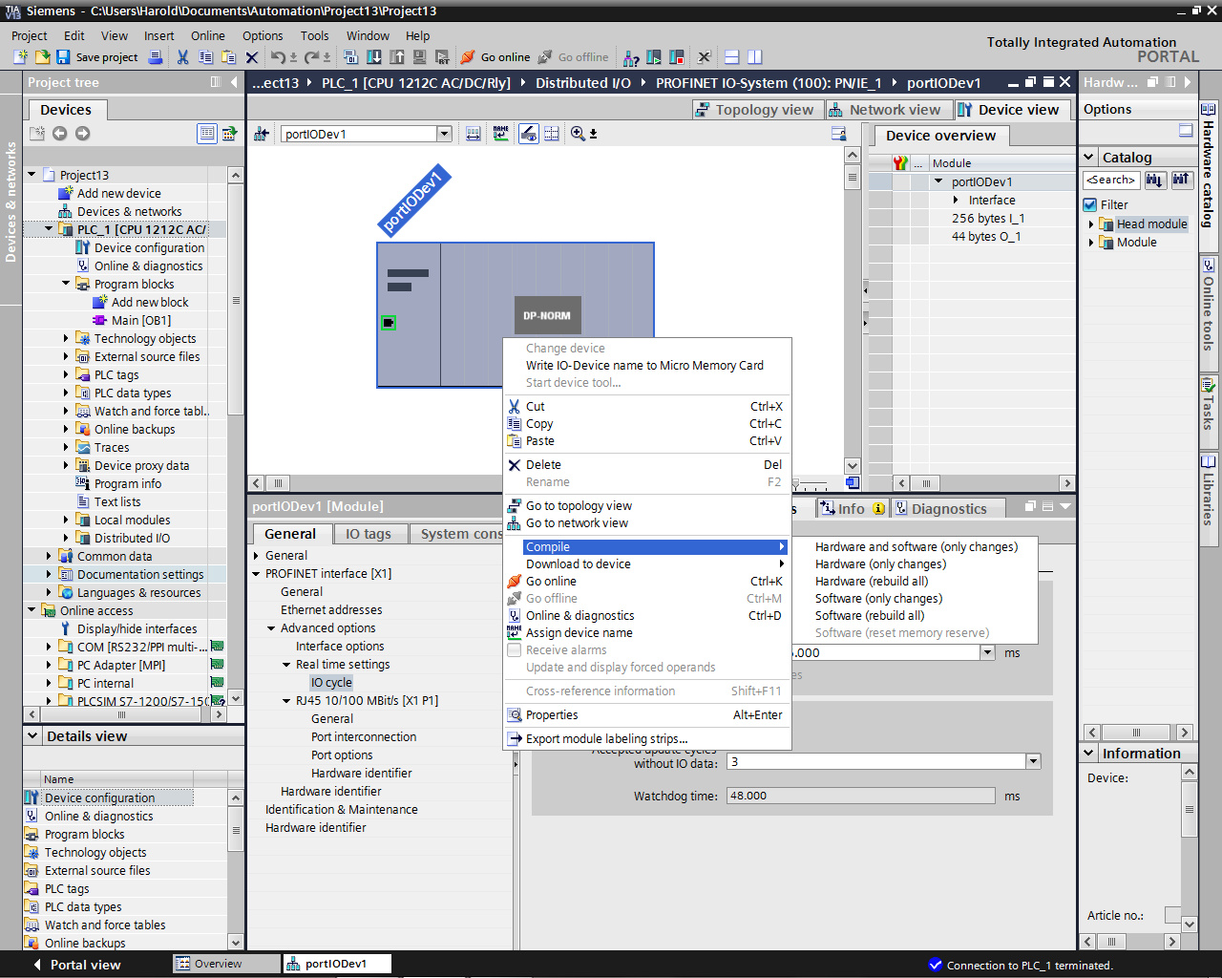

7.3 Go Online
When finishing downloading, Press the “Go online” menu item at the top of the screen.
The “Select device for opening the online connection” menu may appear.
If it does not, Highlight the PLC icon then hit Go Online and the result is the same.
Check the “Go Online” checkbox then the “Go online” button. (See Figure 19)

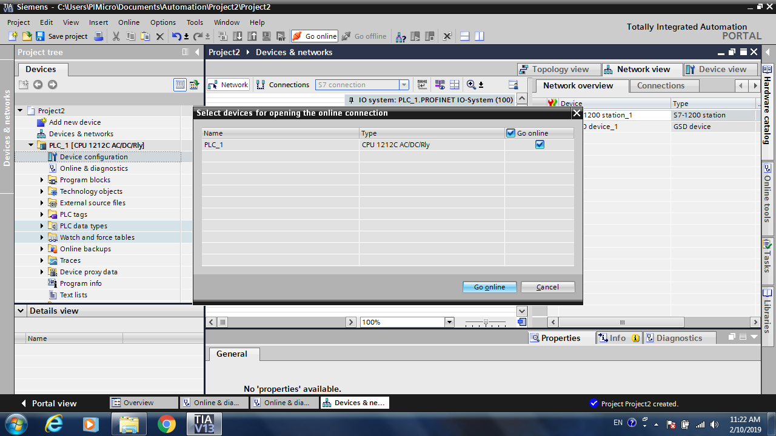

Figure 19 Go Online

7.4 Run PLC
Click Run button in yellow cycle (See Figure 21) to run ST-1200. The Fieldbus LED on Main Screen of INSIGHTqc Controller will turn green.
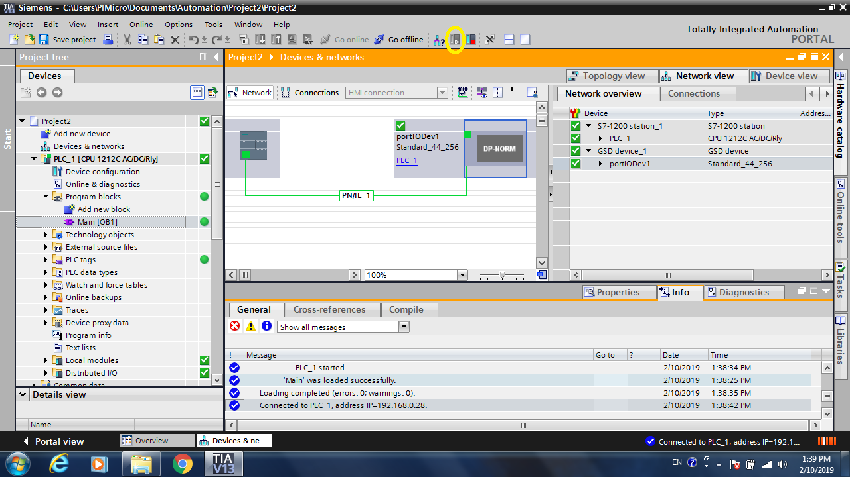
Figure 21. Run PLC

