Insight QC socket tray programming
- How to setup the socket tray in master mode (Simple Socket Tray)

- Go to setup > digital IO and add a module such as shown below (the port number is up to you)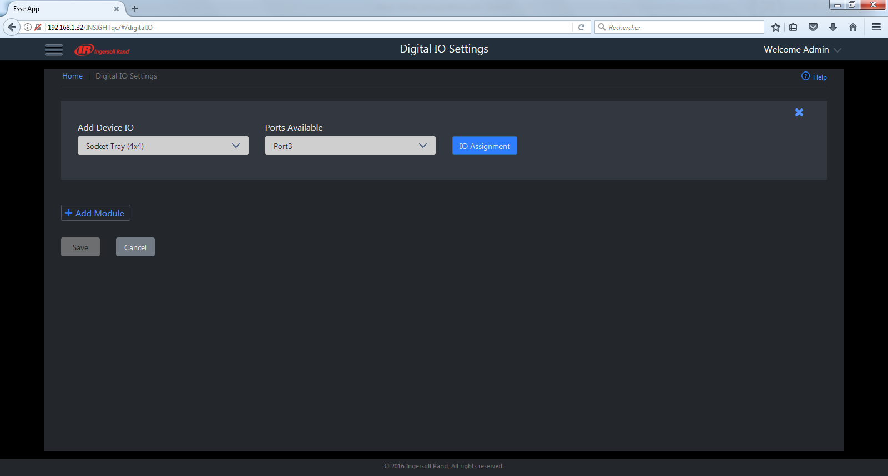
- Click on IO Assignment and edit (click on the pen) to configure inputs and outputs like this :
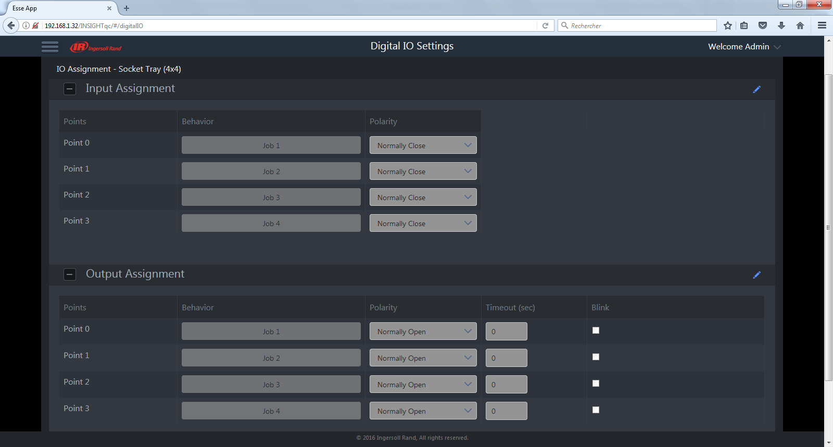
(don’t forget to save at the bottom of the menu page each time you make a change)

- Go to Job Global Settings and select External discrete as Job selection
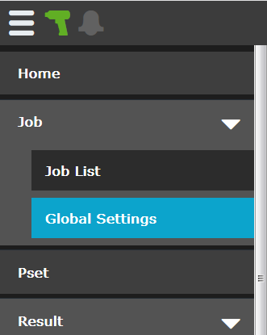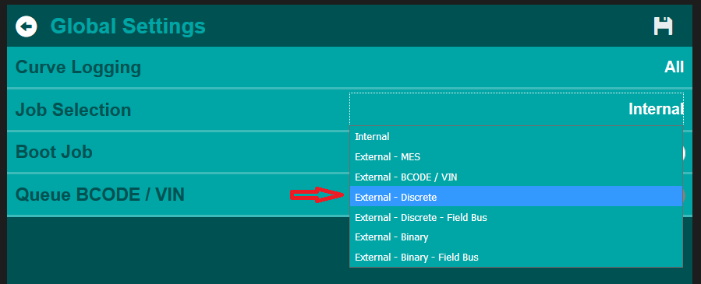
The setup is complete. Pull out a socket and the corresponding Job will be selected.
- How to program the socket tray in slave mode (Smart Socket)
In this mode, the operator will be guided with the LEDs to show what socket to pick. This requires Job selection from some other external device, such as discrete inputs, barcode reader, open protocol, fieldbus, etc.
a) Same as above.
b) Configure the inputs and outputs as shown below:
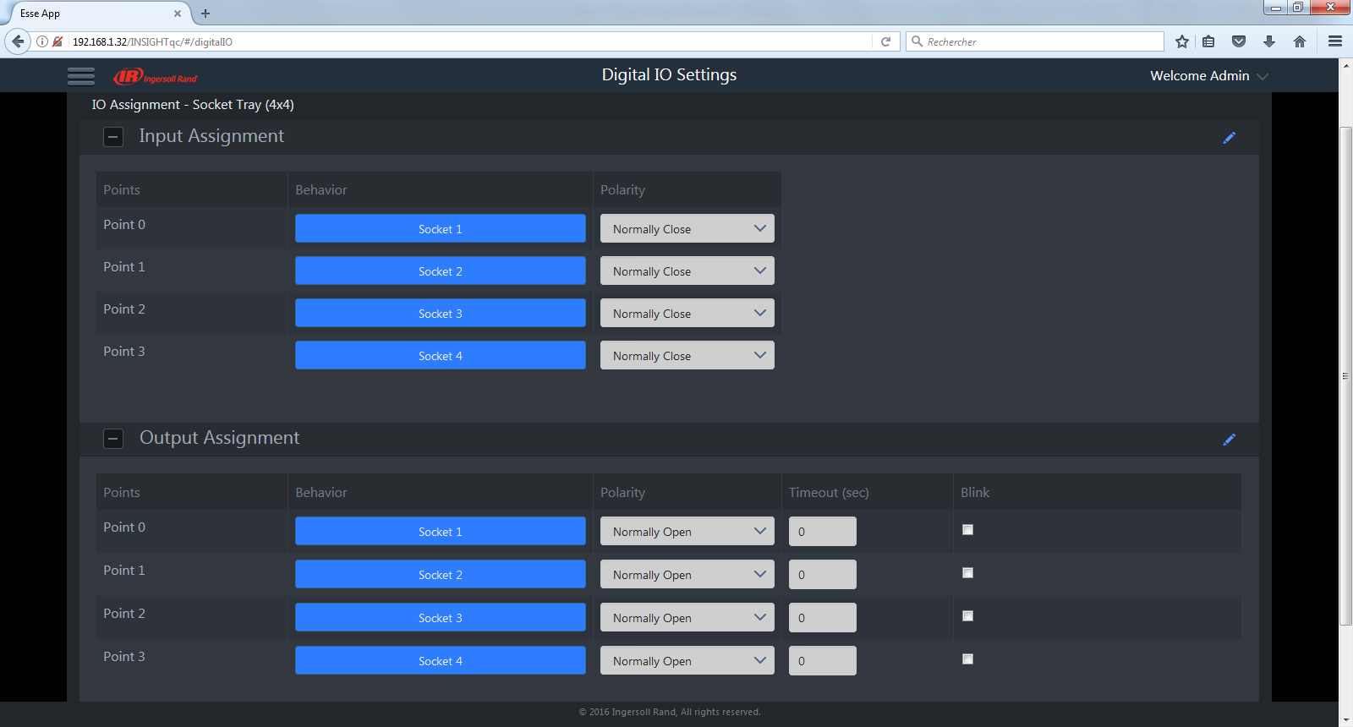

- In the job settings, check the smart socket interlock and assign your socket number at the Pset level:
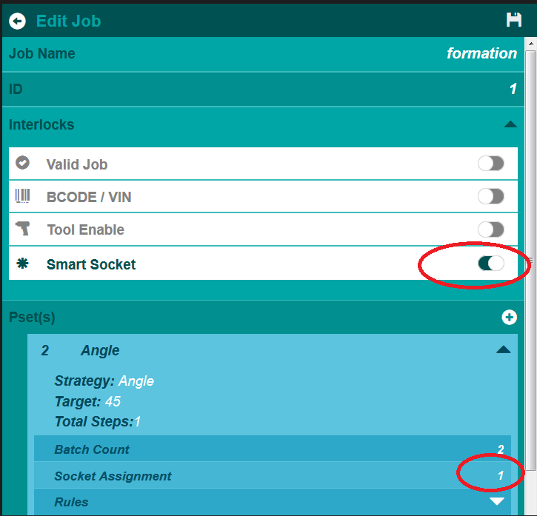
The setup is complete. Select a Job from some external device. The corresponding LED on the Socket Tray will light. Pull that socket and the tool will run the selected Job.

