User Registration:
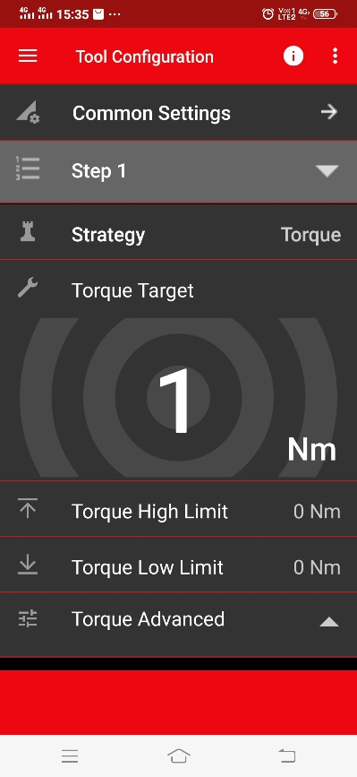
Step1: Download the latest version of app from google play store and open it to get to the home screen. Press Menu icon on top-left of screen to open the side bar.
Menu Icon

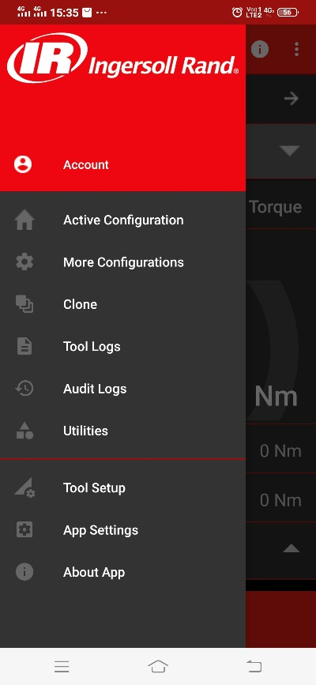
Step2: Press the “Account” link on side bar to navigate to login page.

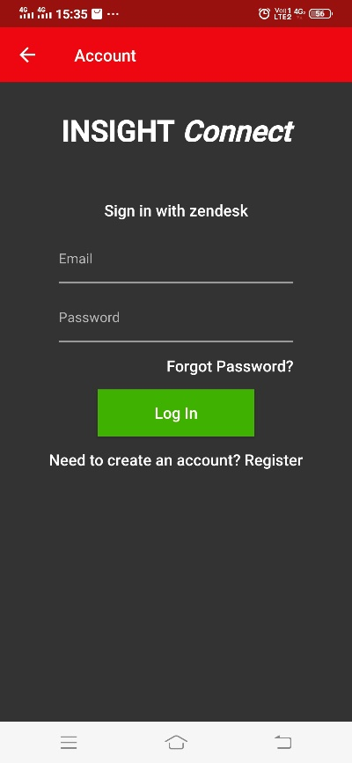
Step 3: Registration page can be reached by pressing the "Register" link on the login page.

Step 4: In order to register, fill out the required fields and press the “Register” button. The following screenshot shows a filled-out registration form.

Registration form contains following fields:
Name: This is where user must enter his name. This is a required field and shouldn’t be blank (e:g : John Doe). There are no other limitations applicable to this field.
Email: This is where user must enter a valid email address. This is a required field and shouldn’t be blank.
(Note: A valid email address consists of an email prefix and an email domain, both in acceptable formats. The prefix appears to the left of the @ symbol. The domain appears to the right of the @ symbol.
For example, in the address example@mail.com, "example" is the email prefix, and "mail.com" is the email domain.
Acceptable email prefix formats
- Allowed characters: letters (a-z), numbers, underscores, periods, and dashes.
- An underscore, period, or dash must be followed by one or more letter or number.
Acceptable email domain formats
- Allowed characters: letters, numbers and dashes.
- The last portion of the domain must be at least two characters, for example: .com, .org, .cc)

Password: Enter a desired password. This is a required field and shouldn’t be blank.
Additionally, it must –
- be at least 6 characters
- be different from email address
- include letters in mixed case and numbers
- include a number, and a character that is not a letter or a number

Confirm Password: This field is required and must contain the exact same password that was typed into the password field.

Step 5: This step is optional and to skip it just press the “Complete Registration” button.
The page contains following fields:

Organization: This is where user enters organization name. It is an autocomplete field, so when user types first three letters and if the matching Organization names already exist then user will see a drop down just below the field, from which user can select the organization. If there are no dropdown results or the organization name is not in the drop down than user must enter the full name (e.g.: Ingersoll Rand).

Site: The format for this field is Organization-Site. Organization name is auto set when user fills out the Organization field, so user should add just the site name to the field. This is also an autocomplete field like Organization, so when user types first three letters of site name, he may see a dropdown list if the site is already created and user can select it from the list. If there are no dropdown results or the site name is not in the drop down, then type the full site name (e.g.: If site name is Bengaluru then field value should be Ingersoll Rand-Bengaluru).

To complete the registration, press the “Complete Registration” button. The following screenshot shows the filled-out form -

