ETS de-activates on its own
As a workaround to this problem, please follow instructions given below:
- When ETS gets disabled inadvertently, blue LED will be OFF on QX Tool back cap. Please look out for blue LED status during fastening operation, especially for Torque strategy when ETS functionality is expected.
- Enable ETS from tool display/back cap :
- With help of down arrow button on tool back cap, scroll to screen with “0000” and select ✔

- Enter password as “FFFF” and select ✔
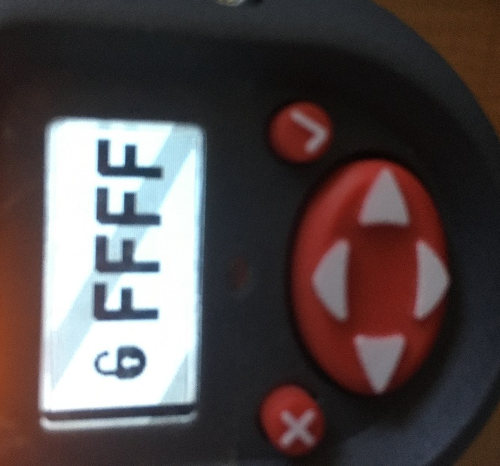

- With help of right arrow button on tool, enter configuration selection screen.

- Select Up arrow button on tool back cap to scroll to ETS selection screen.
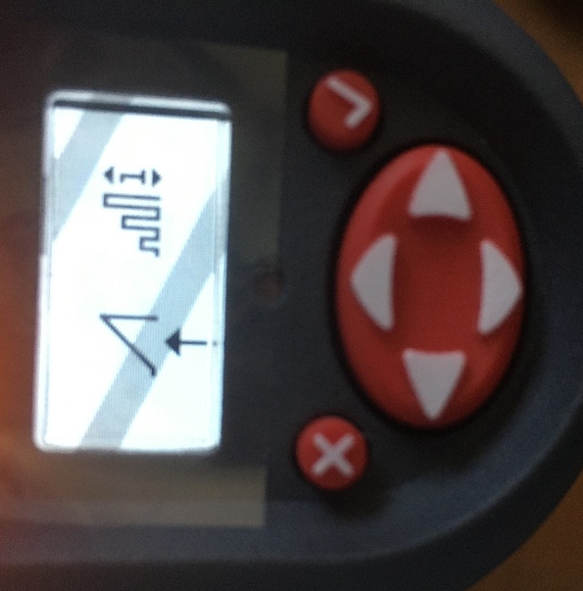
- To enable ETS, scroll to rectangular waveform (with increasing amplitude), and select ✔ on tool.

- ETS enabled tool display:

- ETS parameter selection such as Ergonomics, Performance and Productivity modes cannot be configured from QX Tool back cap. Use ICS software to make these selections.

- ‘Enable ETS’ setting from ICS software:
- Select QX Series on the home screen

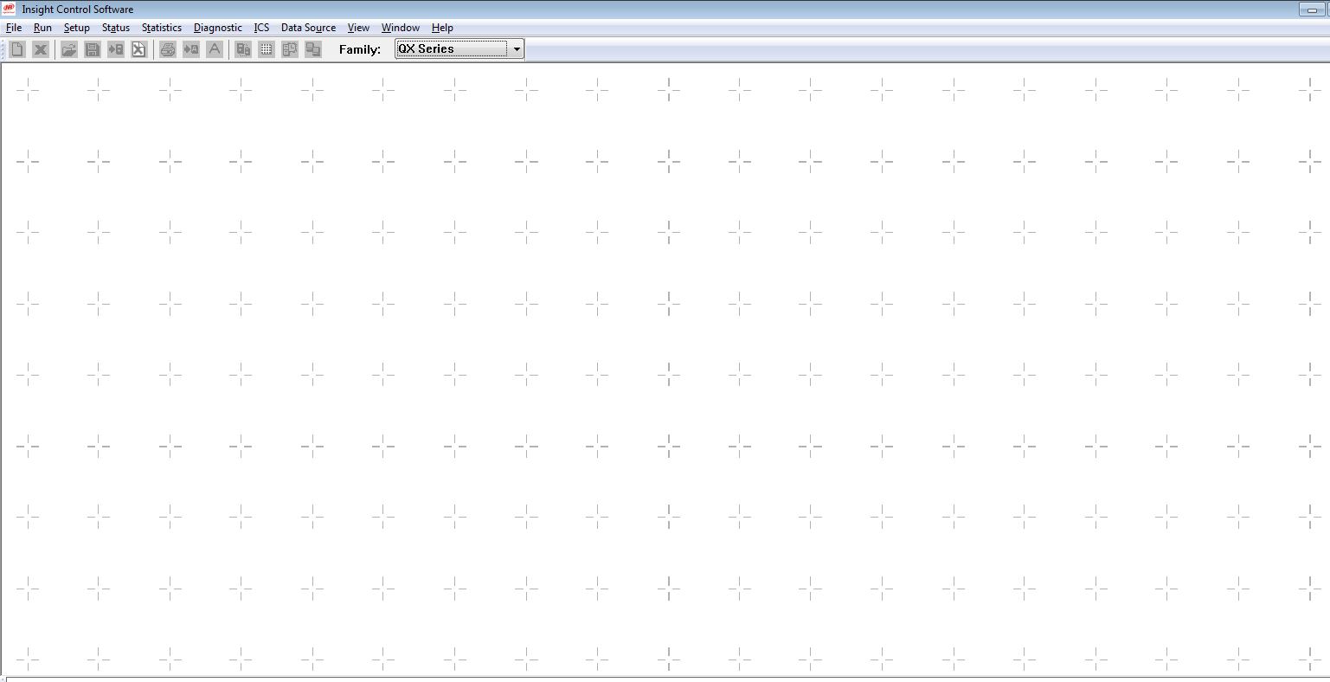

- Select General Setup from Setup menu

- Turn on the checkbox for Enable ETS and save settings.
Note: This is a temporary solution to notify user if ETS gets disabled on its own. This applies to QXX, QXC and QXN tools.

