PFCS setup instructions for PCM.
- Launch “ICS Connect” from programs menu or double click the shortcut on the desktop.
- Select QX series from Family dropdown.

General Setup
- Click on Setup -> IC-PCM 1:1 General Setup.

Controller Selection
- Select the Controller form controller ID dropdown List.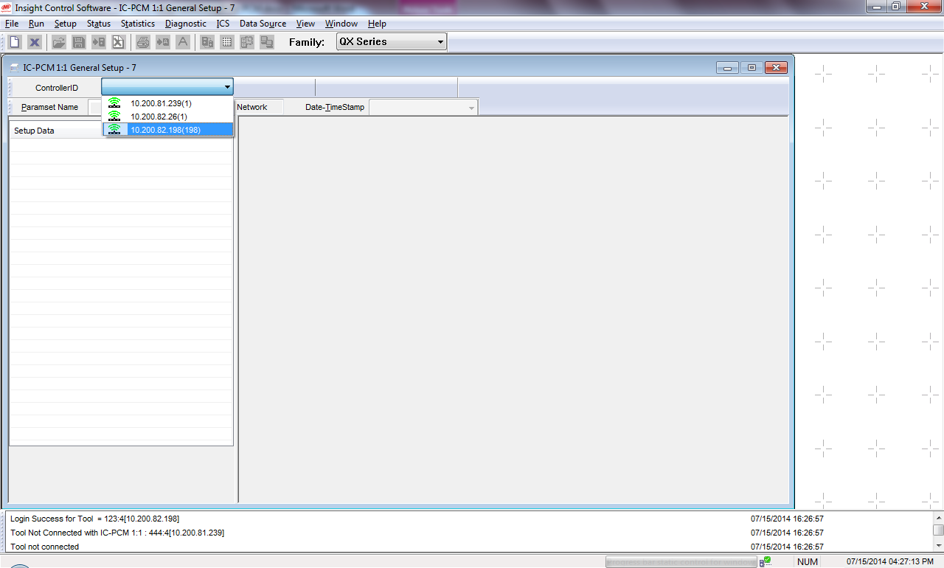

Enable PFCS
- Click on “PFCS Settings” to set the PFCS settings. 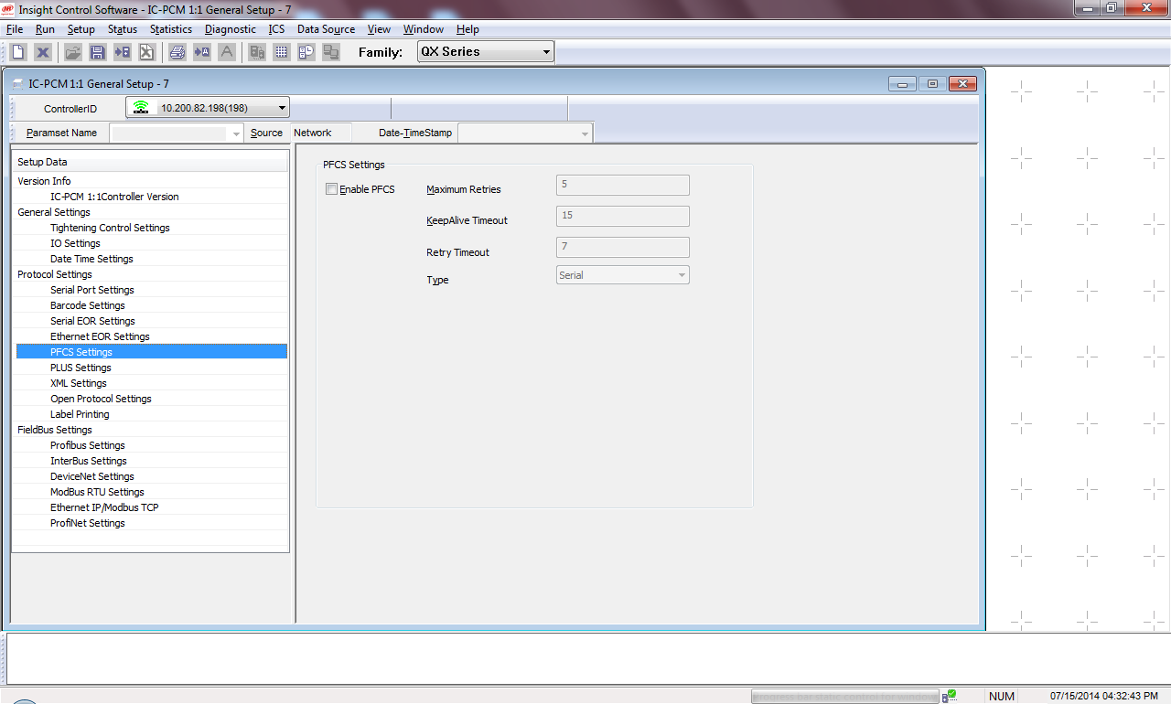
- Click on “Enable PFCS”
- Select “Ethernet” under Type.
- Click on “Enable Unsolicited Port”.
- Enter IP address for the PFD server.
- Enter solicited port.
- Enter unsolicited port.
- Enter solicited Machine ID.
- Enter Unsolicited Machine ID.
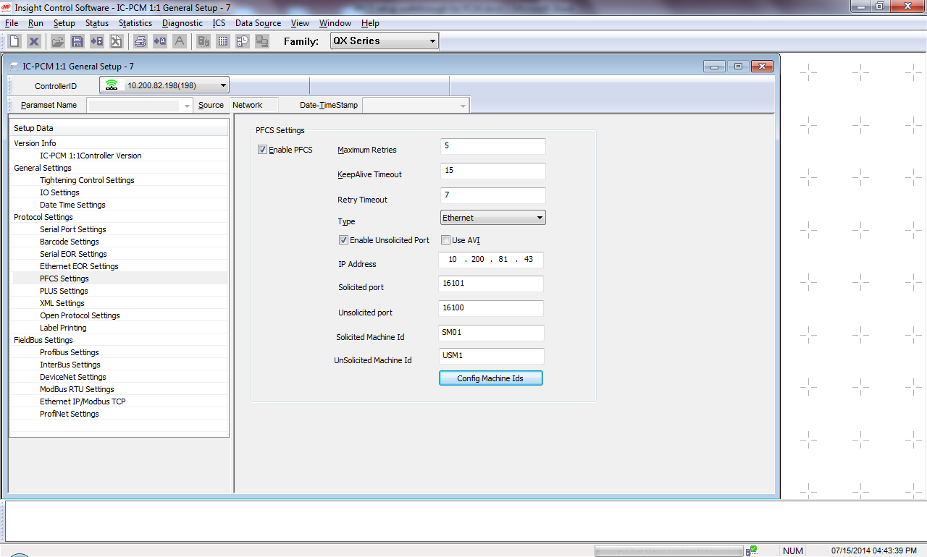

Map Configuration and Machine IDs
- Click on “Config Machine Ids” to enter the Machine ID for each PSet/configs.
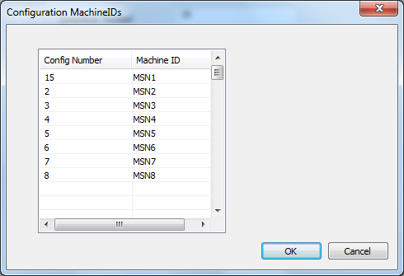

- Click on “Config Machine IDs” button to set Machine IDs for each PSet/configs.
- Once all the settings are in place click on “Send” button.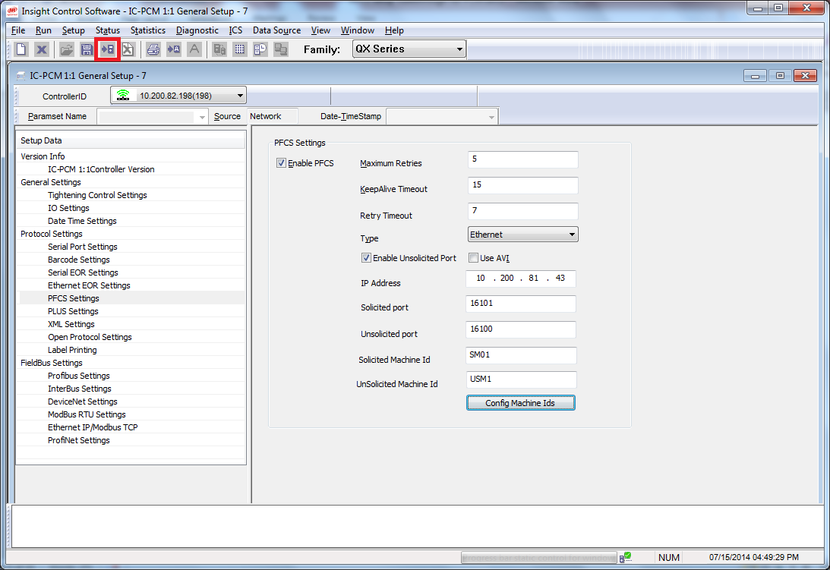

Barcode Setup
- When Enable Unsolicited Port is checked, Barcode is sent as unsolicited message to select a specific config.
- In order to setup the barcode, select the Barcode Settings Tab
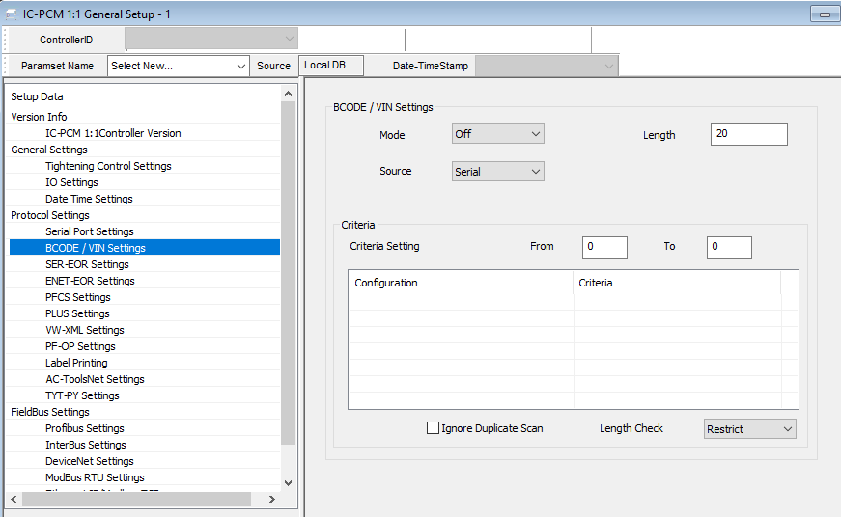

- Barcode can be set to OFF, Active or Passive. Set to Active.
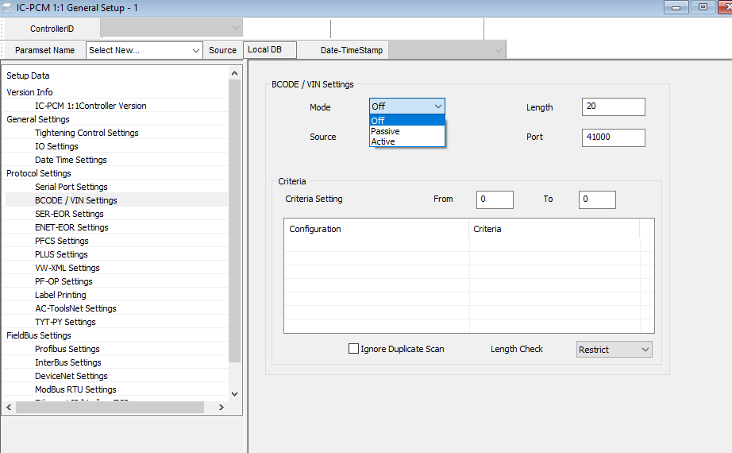

- Set the Length of the barcode as 8.
- Set Criteria setting, 1 in “From” and 8 in “To”.
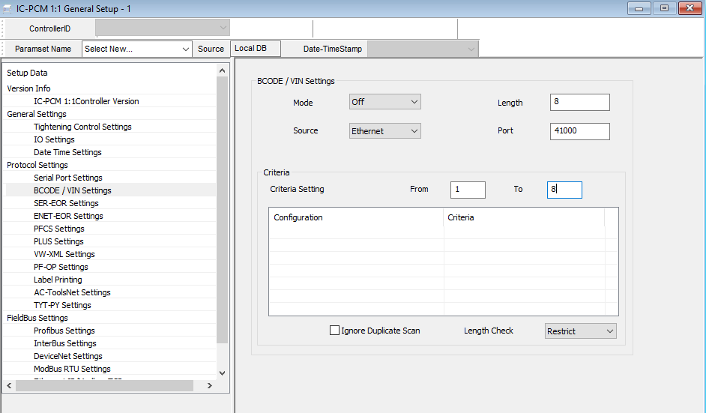
- Double click on the Grid.
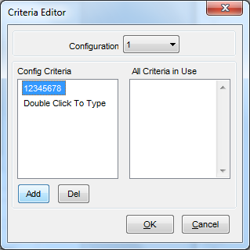
- Click on “Add” button to add the config Criteria.
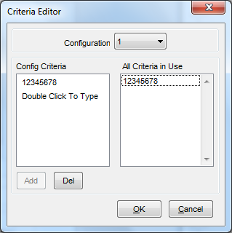
- Repeat the steps for configuration 2 from the dropdown box window.
- Once the settings are complete, click on “OK” and the settings will be reflected as below.
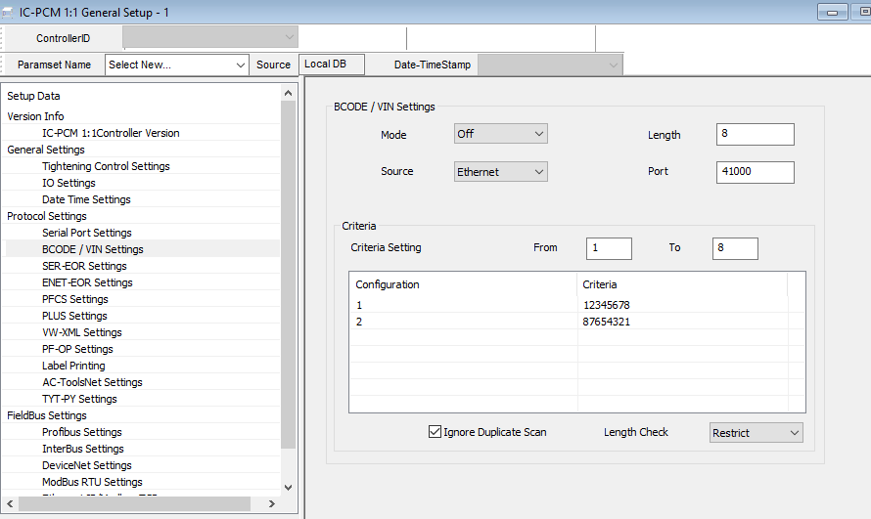

- Click on Send button and reboot controller after 30 sec in order to reflect the changes.

Configuration Selection type
- In order to use PFCS on ICDM controller, Configuration select should be set to “External Ethernet”. This setting can be found under “Setup->General” and “Spindle Initialization” tab. 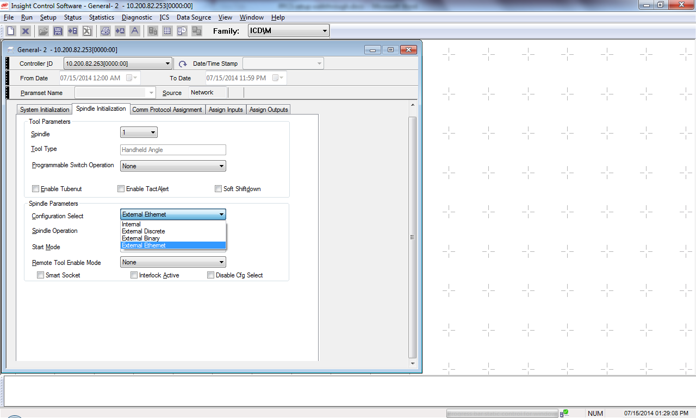
- Click on Send button.

