PFCS setup instructions for ICDM.
- Launch “ICS Connect” from programs menu or double click the shortcut on the desktop.

General Setup
- Click on Setup -> General.

Controller Selection
- Select the Controller from controller ID dropdown List.
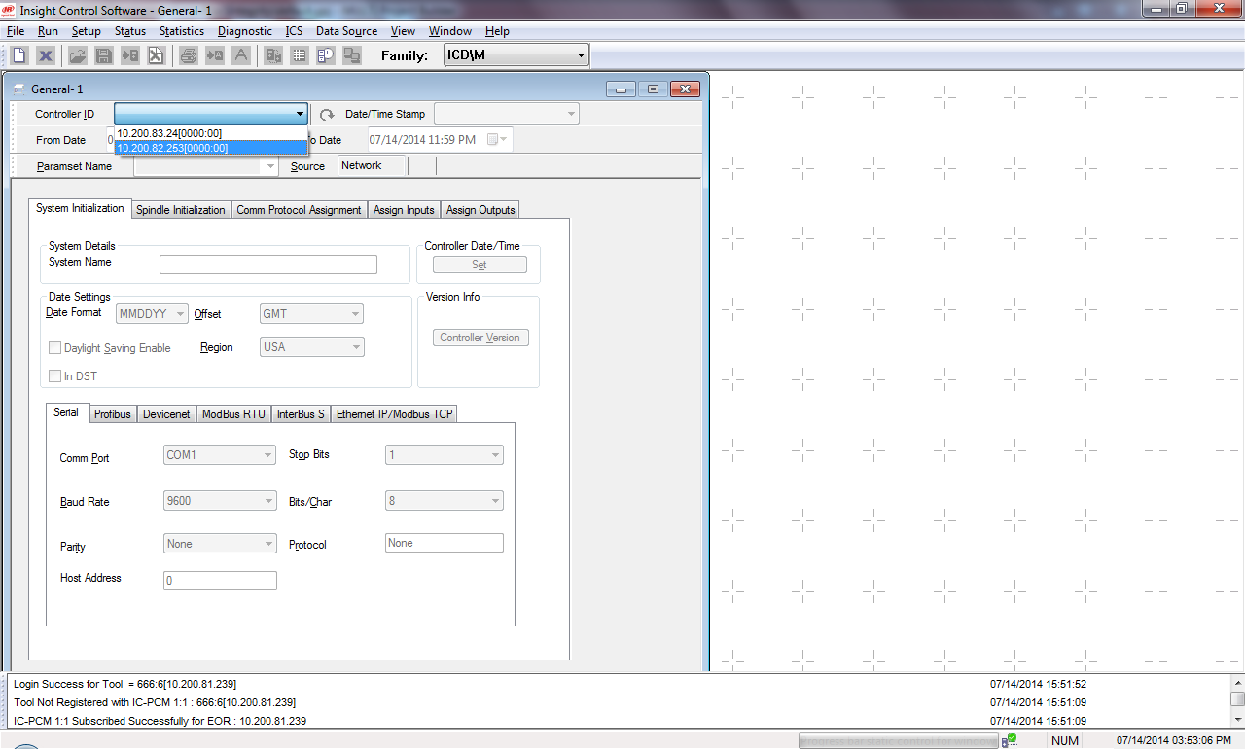

Enable PFCS
- Click on “Comm Protocol Assignment” tab to set the PFCS settings. 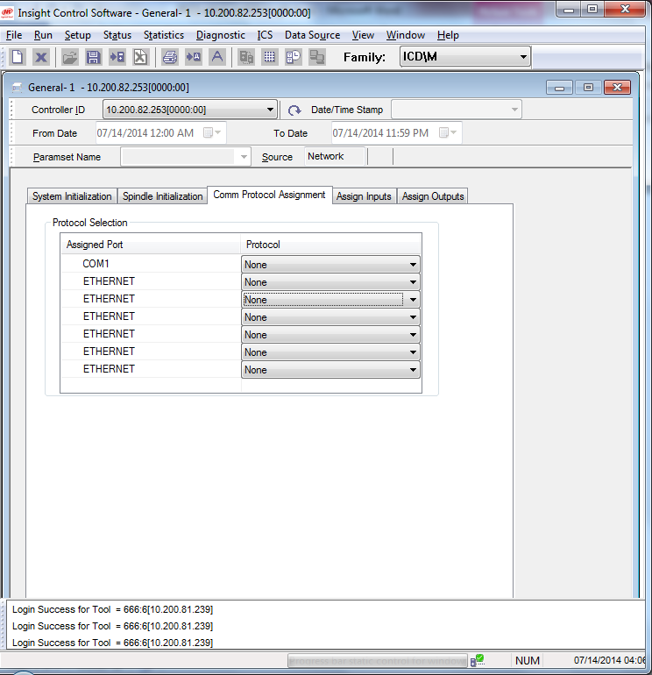
- Select the 3rd dropdown box and select “Single Spindle PFCS”
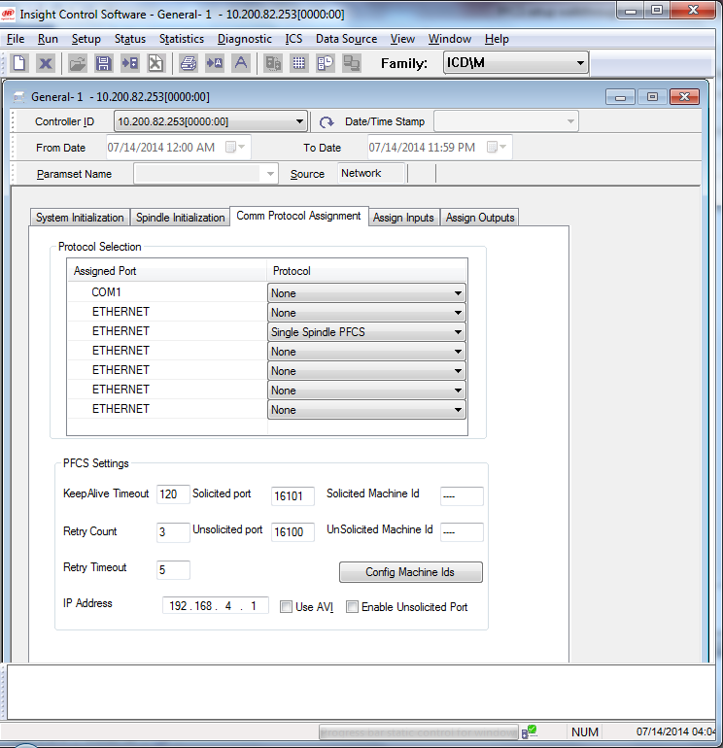
- Make the necessary setting under PFCS settings such as:
- KeepAlive Timeout – Time in seconds for every Keepalive message to send.
- Retry Count – Number of time the Retry should happen.
- Retry Timeout – Time in seconds for the next retry.
- IP Address – PFCS server IP address
- Solicited Port – Port settings for Solicited communication.
- Unsolicited Port – Port settings for unsolicited communication.
- Solicited MachineID – Machine ID for Solicited port
- Unsolicited Machine ID – Machine ID for Unsolicited port.
- Enable/Disable Unsolicited Port – Check the box to enable the Unsolicited Port.
- Config Machine IDs – Machine IDs for the corresponding configs/ pset.

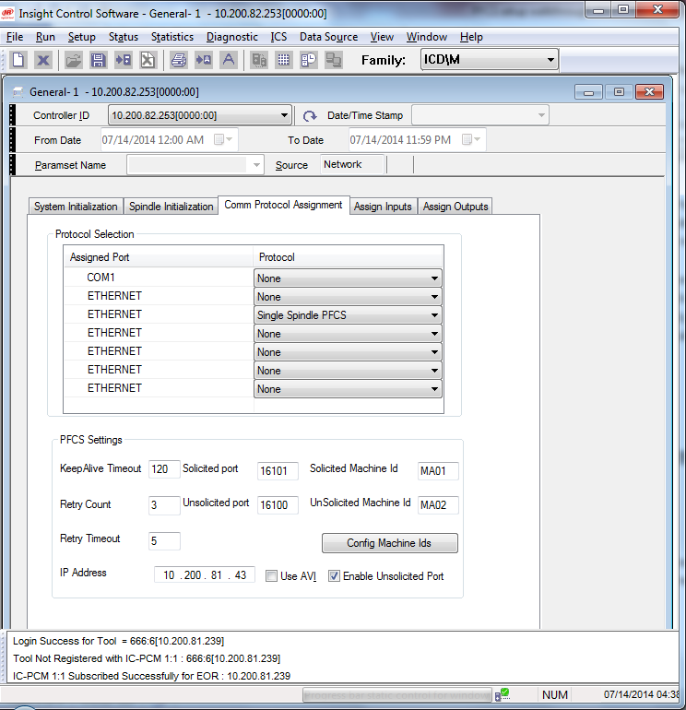

Map Configuration and Machine IDs
- Click on “Config Machine IDs” button to set Machine IDs for each PSet/configs.
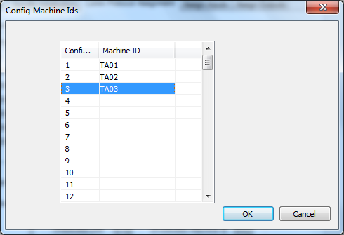
- Once all the settings are in place click on “Send” button.
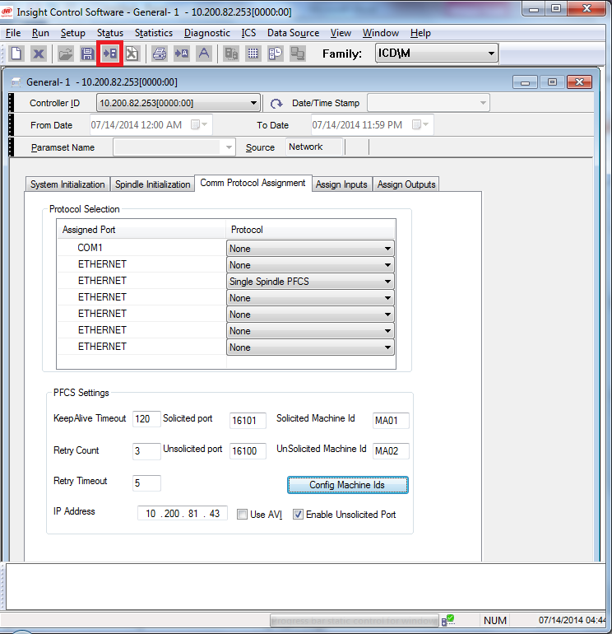

Barcode Setup
- When Unsolicited Port is enabled, Barcode can be sent as unsolicited message to select the config.
- In order to setup the barcode, select the second dropdown box and select Barcode/Vin
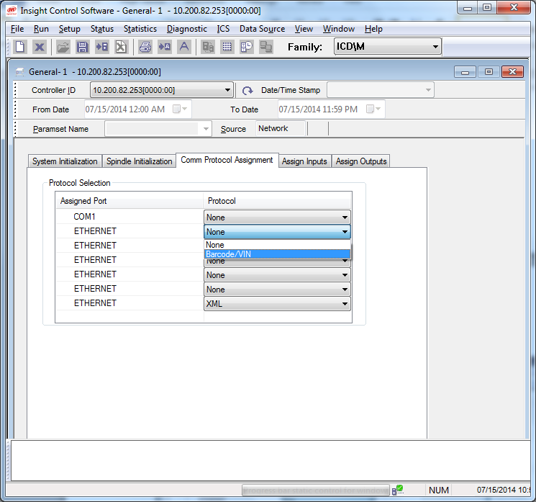
- Barcode can be set to OFF, Active or Passive. Set it to Active.
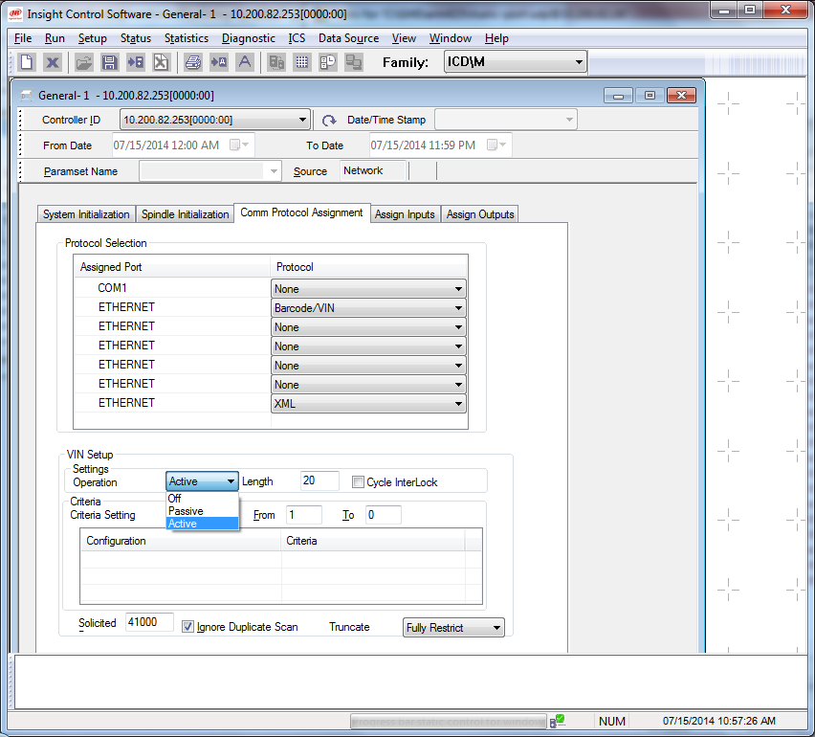
- Set the Length of the barcode as 8.
- Set Criteria setting, 1 in “From” and 8 in “To”.
- Double click on the Grid.
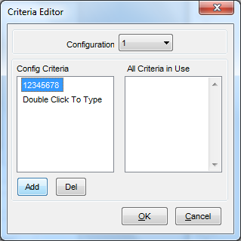
- Click on “Add” button to add the config Criteria.
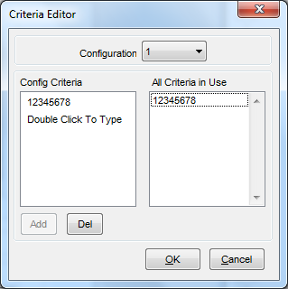
- Repeat the steps for configuration 2 from the dropdown box window.
- Once the settings are complete, click on “OK” and the settings will be reflected as below.
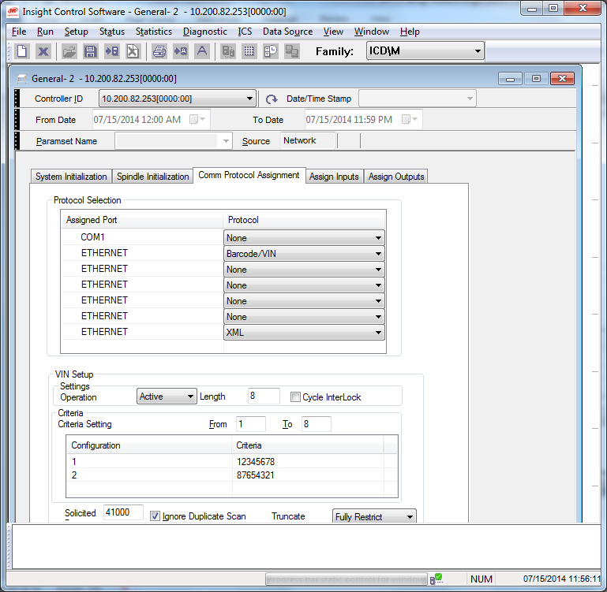
- Click on Send button and reboot controller after 30 sec in order to reflect the changes.

Configuration Selection type
- In order to use PFCS on ICDM controller, Configuration select should be set to “External Ethernet”. This setting can be found under “Setup->General” and “Spindle Initialization” tab. 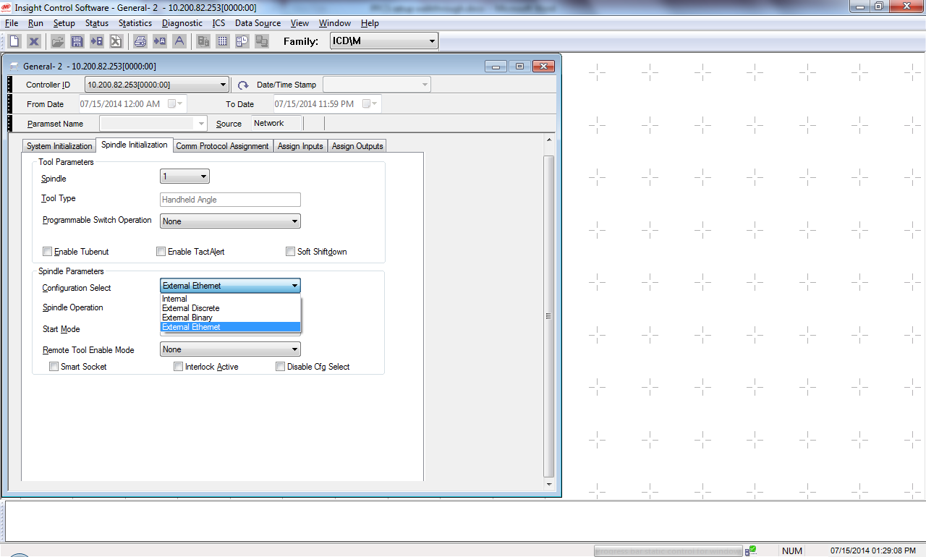
- Click on Send button.
Controller is ready for PFCS protocol communication.

