Instruction Manual to Setup PFCS protocol with INSIGHTqcx Controller and PFCS server.

- Login to the Controller as Admin with valid credentials. Update Advance License to Controller to Enable PFCS Feature
- Open Menu, Go to System Maintenance > Update License
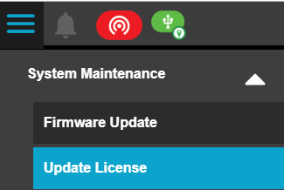

- Activate Demo License or Upload Valid Advance License from License Screen which has PFCS protocol enabled.
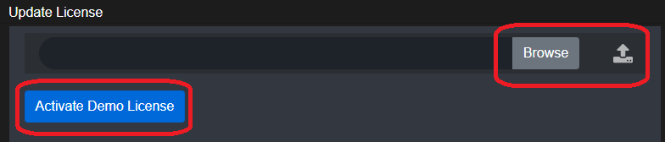

- After updating Advance License, verify in Home screen in Protocol Tile, whether PFCS Protocol is available as shown in the below snapshot.

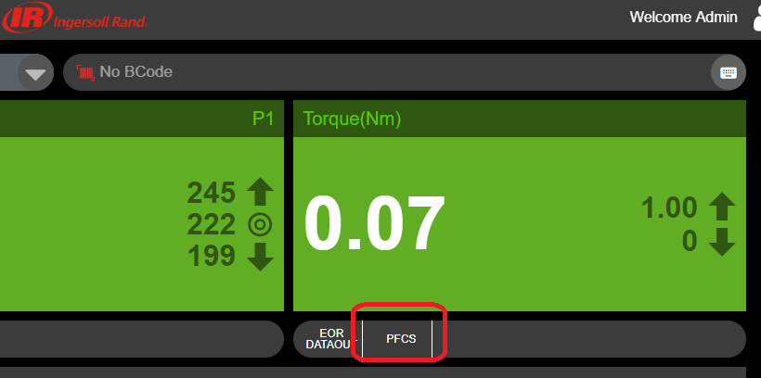

- Go to Menu > Click on Settings and on expanding the Settings Menu, user can see PFCS option. Click on PFCS option which will navigate to PFCS Settings
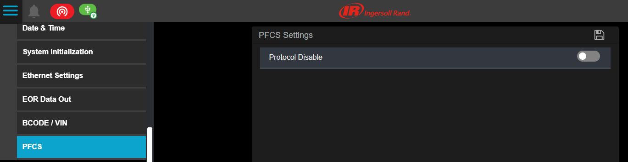

- Enable the PFCS Protocol by clicking the button, there will be a warning message to Enable Barcode settings. This alert message is to Setup Barcode for attaching Barcode with EOR and for Job selection if communication mode is Unsolicited. User can select Ok to “Please Enable barcode settings” prompt and can set up barcode settings later. After this step, user can Enable PFCS protocol.
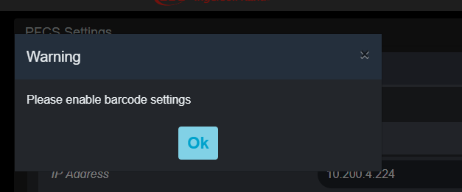

- Once user Enables PFCS Protocol, user will be seeing the following below other PFCS settings option.
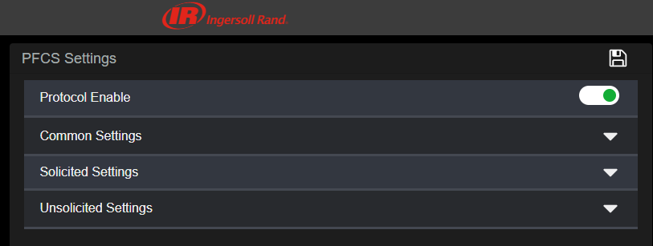

- Configure IP Address in PFCS Settings Enter the IP address of the system where the PFD server is
Running.
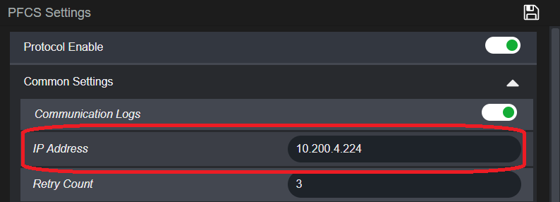

Enable Solicited Mode
- Go to Solicited Settings, Enable Solicited Status, Enter Solicited Machine ID, Enter Solicited Port Number
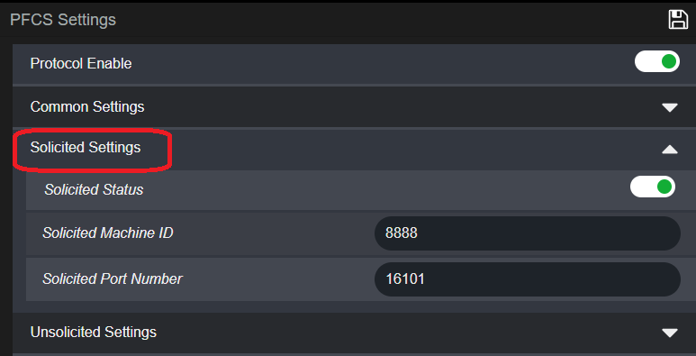

Enable Unsolicited Mode
- Go to Unsolicited Settings, Enable Unsolicited Status, Enter Unsolicited Machine ID, Enter Unsolicited Port Number

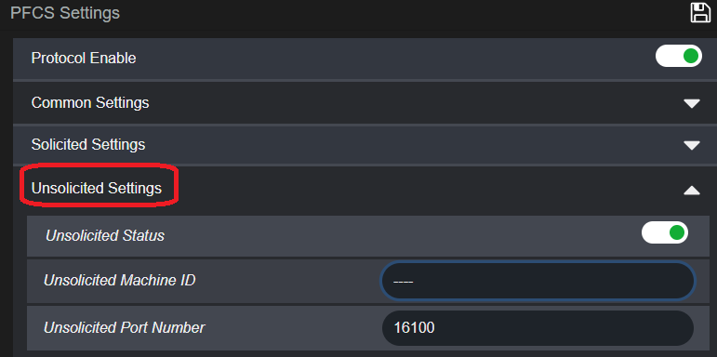

Map Jobs and Machine IDs
- Go to Common Settings > Go to Pair Job and Click on Pair Machine ID button

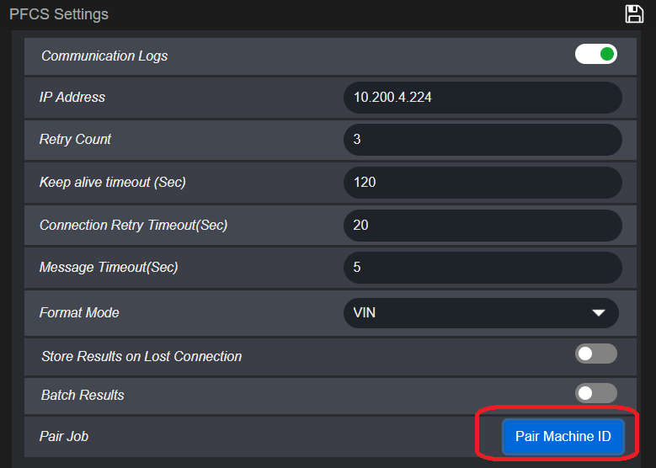

- Enter Machine ID for each Jobs and click on Apply button
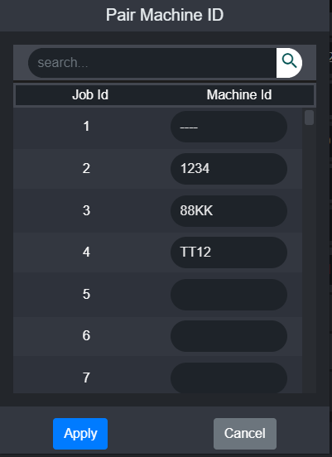

- Configure all parameters (Keep alive timeout, Retry Count , Format mode etc. ) as required from Common Settings
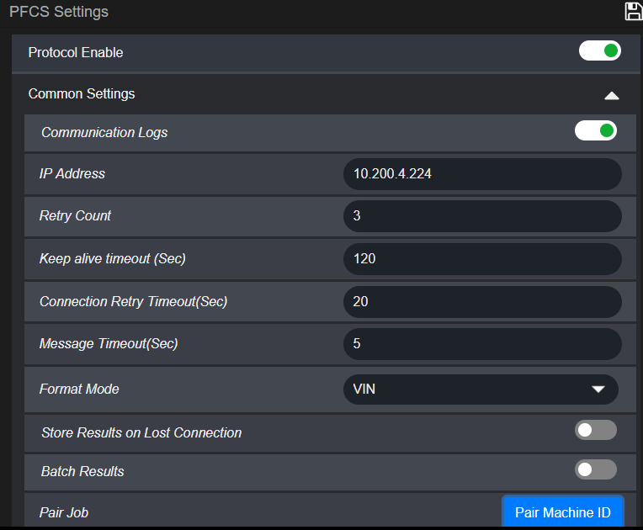

- Click on Save button to Save PFCS settings successfully.

Barcode Setup
- Go to Settings > Click on BCODE / VIN Option
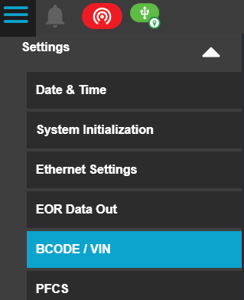

- Enable BCODE / VIN

- Select the Barcode Source (Manual, Ethernet, Serial, USB, MES, Fieldbus) from Select Source option
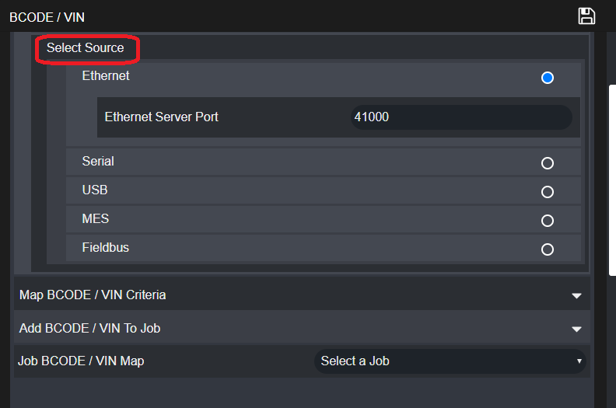

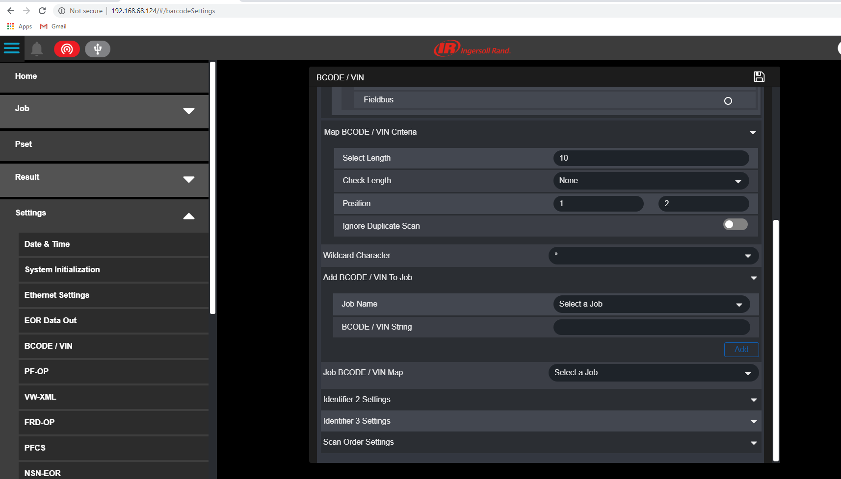
- Set BCODE / VIN Criteria and Add BCODE to Job

- Save BCODE / VIN Settings

- Select the appropriate Job Selection Mode
  - If barcode comes from the PFCS then the Job Selection is set to Extermal MES
  - If barcode comes from a local scan or other source, set to External BCode/VIN
